

Climate-Vulnerability Assessments for Ada East District Assembly Report

Developed by:

Foresight Planners Africa Limited


P.O BOX LG 88
University of Ghana LEGON, ACCRA

Tel: 0244269073/
Email: bobmanteaw@foresightplanners.com/rmanteaw@ug.edu.gh

TO:

EPA/IISD/ NAP GLOBAL NEWTWORK



Table of Contents

Table of Contents I
List of figures III
List of tables IV
Acronyms V
Executive Summary VI
CHAPTER 1 1
1.1 BACKGROUND 1
1.2. Purpose and objective of the vulnerability assessment 2
1.3 Scope of VA 3
1.4 Outputs of the VA 5
1.5 Guiding Principles 6
1.6 Definition of key terms and concepts 7
1.7 Methodological Framework for the VA Process 9
CHAPTER 2 - DISTRICT PROFILE 12
2.1 Location and size 12
2.2 Demographic overview 13
2.3 Administration and governance 15
2.4 Physical and environmental features 15
2.5 Economic overview (major economic sectors vulnerability to climate change) 16
CHAPTER 3 – ASSESSMENT OF VULNERABILITY TO CURRENT CLIMATE CHANGE 19
3.1 Analysis of the Observed Climate Changes 19
3.2 Qualitative Assessment of Vulnerability to Current Climate Change 23
3.3 Quantitative Assessment of Vulnerability to Current Climate Change 42
Sampling Methodology for Ada East District 43
CHAPTER 4: ASSESSMENT OF VULNERABILITY TO FUTURE CLIMATE CHANGE 74
4.1 Climate Change Projections 74
4.2 Potential Impacts and Future Climate Change Risk 79
CHAPTER 5 – IMPLICATIONS FOR ADAPTATION PLANNING 82
5.1 Introduction 82
5.2 Conclusions 84
REFERENCES 86
APPENDICES 93
Appendice 1 – Matrix of Function 93
Appendix 2 – Variables for LVI 97
Appendix 3 – Sectoral LVI Variables 101

List of figures
Figure 1 : The Vulnerability Assessment Process 9
Figure 2 : Map of Ada East District (Source: Ghana Statistical Service, GIS) 13
Figure 3 : Age Distribution of Population In Ada East Dstrict 14
Figure 4 : Digitalised image of stakeholder (group) representation of district seasonal calendar 22
Figure 5 : Images of Stakeholders at District-Specific Vulnerability Assessment Validation of Adaptation Strategies Workshop workshop organised on April 29th, 2025 24
Figure 6 : Visualisations of critical infrastructure, key resources and vulnerable areas, Ada East District 35
Figure 7 : Stakeholders Ranking on the Impact of Climate Hazards on Gender groups 39
Figure 8 : Grouping of major and subcomponents/indicators into LVI and LVI–IPCC 47
Figure 9 : Levels of education across communitties in Ada East District 50
Figure 10 : Primary occupation of respondents 51
Figure 11 : Household dependents 52
Figure 12 : Period of stay in communities 53
Figure 13 : Household Members Working Outside 54
Figure 14 : IPCC-LVI heat map for economic sectors in Ada East District 62
Figure 15 : IPCC-LVI heat map of Communities’ Vulnerability 62
Figure 16 : Climate Exposure of Ada East 67
Figure 17 : Climate Sensitivity of Ada East District - Heat map 68
Figure 18 : Adaptive Capacity Heat Map of Ada East District 69
Figure 19 : Household Decision Making 70
Figure 20 : Household Tasks roles and responsibility 71
Figure 21 : Women Climate Adaptive Capacity 72
Figure 22 : Access to resources 73
Figure 23 : Yearly RainfallTrend (Downscaled) 76
Figure 24 : Precipitation indices trend (RR, Rx1, Rx5, R20mm, R95p, CDD, CWD, etc.) 76
Figure 25 : Monthly cycle of rainfall projections 77
Figure 26 : Yearly Temperature Trend (Downscaled) 78
Figure 27 : Monthly cycle of temperature projections 78
Figure 28 : Temperature indices (TX90p, TX10p, TN90p, TN10p, DTR) 78

List of tables
Table 1 : Observed Natural Hazard and Extreme Events in Ada East District 26
Table 2 : Ranking of the most important and vulnerable economic sectors to climate cange 37
Table 3 : Population Sampling for Ada East District 44
Table 4 : Gender and Age distribution of the respondents 48
Table 5 : Sectoral Vulnerability of Ada East District 57
Table 6 : IPCC‑LVI results for Ada East District 63

Acronyms
Abbreviation | Connotation
AEDA | Ada East District Assembly
EPA | Environmental Protection Agency
GSS | Ghana Statistical Service
IPCC | Intergovernmental Panel on Climate Change
LVI | Livelihood Vulnerability Index
NADMO | National Disaster Management Organization
NAP | National Adaptation Plan
SDGs | Sustainable Development Goals
UNDP | United Nations Development Programme
UNEP | United Nations Environment Programme
WASH | Water, Sanitation and Hygiene
VRA | Volta River Authority
GMA | Ghana Meteorological Agency
ISSER | Institute of Statistical, Social and Economic Research
DRR | Disaster Risk Reduction
MoFA | Ministry of Food and Agriculture
WHO | World Health Organization

Executive Summary
Background: Ada East District, located between the Volta River and the Gulf of Guinea, is one of the most climate-vulnerable coastal areas in Ghana. Its geographical position exposes communities to tidal surges, flooding, saltwater intrusion, shoreline retreat, and prolonged dry spells. The district’s economy is anchored in agriculture, fishing, and salt mining—livelihoods that are highly sensitive to climate variability and environmental pressures. Rapid ecosystem degradation, coupled with persistent socio-economic challenges such as poverty and fragile infrastructure, compound these risks, making climate resilience a pressing development priority.
Methodology: The Climate Risk and Vulnerability Assessment (CRVA) applied a mixed-methods approach to capture both scientific and community perspectives:
Household Surveys: Structured questionnaires across coastal, inland, and island communities gathered data on livelihoods, water, health, and coping mechanisms.
Analytical Frameworks: The Livelihood Vulnerability Index (LVI) and the IPCC framework for exposure, sensitivity, and adaptive capacity were applied to integrate climate data with household-level experiences.
Participatory Consultations: Workshops and interviews with traditional leaders, women’s associations, youth, and persons with disabilities ensured inclusive representation and fostered ownership of findings.
Key Findings
a. Spatial and Demographic Vulnerabilities
- Coastal Settlements: Tidal surges, coastal flooding, and shoreline erosion threaten low-lying communities such as Big Ada, leading to recurrent displacement and asset losses.
- Inland Communities: Erratic rainfall and prolonged droughts disrupt maize, cassava, and vegetable production, undermining food security.
- Island Communities: Settlements on the Volta estuary face multiple disadvantages, including limited access to markets, potable water, and health facilities.
b. Sectoral Vulnerabilities
- Agriculture: Rainfed farming is increasingly unreliable due to erratic rainfall, saline intrusion, and soil degradation. Yields of staple crops are falling.
- Fisheries: Declining fish stocks, driven by salinity changes and ecosystem degradation, undermine fishing livelihoods.
- Water Resources: Many households rely on costly purchased water due to saline intrusion and unreliable sources.
- Health: Outbreaks of climate-sensitive diseases such as cholera and malaria follow floods, while inadequate health infrastructure exacerbates risks.
- Infrastructure: Poorly adapted roads, schools, markets, and drainage systems suffer recurrent damage from floods and tidal surges.
- Ecosystems: Mangrove and wetland degradation in the Songor Lagoon and Volta estuary reduce natural protection and weaken fisheries and biodiversity.
- Governance: Disaster preparedness is constrained by weak institutional coordination and limited resources for NADMO.
c. Gender and Social Dynamics
- Women, who play central roles in farming, fish processing, water collection, and trading, face restricted access to land, credit, and decision-making.
- Men dominate sole financial and farming decisions, undervaluing women’s contributions.
- Women’s unpaid workloads—particularly in water collection and childcare—increase significantly during climate crises.
- Persons with disabilities and marginalized groups have limited livelihood opportunities and weak social protection, reducing their adaptive capacity.

Recommendations:
- Climate-Resilient Livelihoods: Promote drought-tolerant and salt-resistant crops, expand aquaculture, and provide microfinance, especially for women farmers and traders.
- Water Security: Scale up the District Water Supply Scheme, drill boreholes, and promote rainwater harvesting to ensure safe and reliable water access.
- Infrastructure Resilience: Complete sea defense projects, improve drainage in Kasseh and Big Ada, and enforce land-use planning to protect lives and assets.
- Public Health Preparedness: Strengthen disease surveillance, expand sanitation facilities, and scale up WASH programs in flood-prone and coastal communities.
- Ecosystem-Based Adaptation: Restore mangrove forests, enforce conservation rules, and link ecosystem rehabilitation to alternative livelihoods.
- Gender and Social Inclusion: Form women-led adaptation groups, mainstream gender in district planning, and expand social protection for marginalized groups.
- Governance and Institutional Capacity: Strengthen NADMO logistics, integrate climate risks into district plans, and support community-based early warning systems.

Conclusion: Ada East District’s vulnerability is driven by geographical exposure, fragile infrastructure, ecosystem degradation, and entrenched social inequalities. Communities across the coastal, inland, and island zones face overlapping risks of flooding, erosion, drought, and salinization, with agriculture and fisheries most affected. Women, persons with disabilities, and marginalized groups bear disproportionate burdens due to structural inequalities and limited support systems. Urgent investments in livelihoods, water security, infrastructure resilience, health systems, ecosystem restoration, and inclusive governance are needed to secure the district’s climate-resilient development pathway.

CHAPTER 1

1.1 BACKGROUND
Climate change is intensifying the frequency and severity of natural hazards worldwide, with profound social, economic, and environmental consequences. Rising sea levels, shifting rainfall patterns, and increasing temperature extremes are driving heightened exposure to floods, droughts, storms, and coastal erosion (IPCC, 2021). Community vulnerability to these risks is shaped not only by biophysical processes but also by socio-economic conditions such as poverty, livelihood dependence, and governance structures (Birkmann et al., 2022). Against this backdrop, vulnerability and risk assessments have become essential for identifying at-risk populations, prioritizing adaptation actions, and guiding evidence-based policymaking (Sethamo & Harder, 2021).
In Africa, climate change compounds existing development challenges and amplifies inequalities across rural and urban contexts. Many countries already face climate-related stresses on food security, water resources, and public health (Serdeczny et al., 2017). Evidence shows that limited adaptive capacity, coupled with heavy reliance on climate-sensitive livelihoods such as agriculture and fisheries, heightens vulnerability to environmental hazards (Makondo & Thomah, 2024). These realities reinforce the importance of locally grounded, context-specific vulnerability assessments that integrate scientific analysis with community-based knowledge (Letsyo, 2015).
Ghana, like many West African countries, has undergone a shifting risk profile, with rising temperatures, unpredictable rainfall, more frequent extreme events, and growing socio-economic pressures. Increasing incidences of flooding, drought, coastal erosion, and land degradation are undermining sustainable development (Johnson, 2024). Vulnerability is spatially differentiated: the northern savannahs are more exposed to drought, while southern coastal areas face greater risks of flooding and erosion (Adaawen, 2021; Boafo, Lah & Manteaw, 2025). Socio-economic vulnerabilities are equally significant, as a large share of the population depends on rain-fed agriculture, fisheries, and informal economic activities—sectors highly sensitive to climate variability (Osei, 2024).
Ghana’s coastal zones present particularly acute risks. Rapid urbanization, unsustainable land use, and weak enforcement of planning regulations have intensified the impacts of climate hazards (Appeaning Addo et al., 2023). Shoreline retreat, saltwater intrusion, and storm surges disrupt settlements and livelihoods, especially for communities dependent on fishing and small-scale agriculture (Ankrah et al., 2023). Social dimensions such as poverty, limited access to early warning systems, and weak disaster preparedness further exacerbate vulnerability (Pienaah et al., 2023). These risks point to the urgent need for district-level vulnerability assessments to inform adaptation planning and policy.
Ada East District in the Greater Accra Region exemplifies these challenges. Its geographical location at the Volta River estuary exposes it to multiple climate-induced risks, including flooding, shoreline erosion, and saltwater intrusion (Abu et al., 2022). Local livelihoods, particularly fishing and small-scale farming, are highly climate-sensitive, while poverty, inadequate infrastructure, and weak disaster preparedness increase social fragility (Pienaah et al., 2023). The intersection of biophysical exposure and socio-economic vulnerability makes Ada East a priority area for systematic climate risk assessment.
Addressing these challenges requires robust frameworks and tools to evaluate the district’s exposure, sensitivity, and adaptive capacity. A comprehensive Vulnerability and Risk Assessment for Ada East would enable district authorities and national institutions to identify the most at-risk communities, design context-appropriate interventions, and minimize maladaptation. Beyond the district, such an assessment would contribute to national adaptation goals by strengthening evidence-based decision-making and aligning local actions with Ghana’s climate policy commitments.

1.2. Purpose and objective of the vulnerability assessment
This Vulnerability and Risk Assessment (VRA) report has been developed for the Ada East District to provide a systematic understanding of the district’s exposure, sensitivity and adaptive capacity to climate-related hazards. The assessment serves as a foundation for evidence-based decision-making and provides a critical knowledge base that stakeholders can draw on to guide future climate risk management and development initiatives.
The specific aims are to:
- Identify and analyze key climate-related and non-climatic hazards affecting Ada East District, with a focus on flooding, coastal erosion and saltwater intrusion.
- Assess the vulnerability and risk profiles of communities, sectors and livelihoods by examining exposure, sensitivity and adaptive capacity across social, economic and environmental dimensions.
- Map and document the spatial distribution of risks to highlight the most exposed and least resilient areas, thereby providing baseline data for integration into district development and disaster risk management strategies.
- Produce knowledge products that enhance awareness, inform decision-making, and facilitate resource mobilization for adaptation finance.
- Strengthen local ownership and capacity by engaging stakeholders particularly women, youth, migrants and persons with disabilities in participatory processes that build knowledge, validate findings, and co-create adaptation strategies.
- Contribute to national adaptation efforts by feeding Ada East District’s insights into regional synthesis reports and the national knowledge base, thereby supporting Ghana’s reporting under the UNFCCC, NDCs, and Sustainable Development Goals (SDGs).

1.3 Scope of VA
Sectors: The Vulnerability and Risk Assessment (VRA) adopts a cross-sectoral approach, recognizing that climate change impacts are interconnected and often cascading. The analysis focuses on key sectors that are particularly exposed in Ada East, including agriculture (crops, livestock and fisheries), health and sanitation, water resources, transportation and physical infrastructure, biodiversity and natural resources, as well as tourism. This sectoral framing is consistent with Ghana’s National Adaptation Plan (NAP) Framework, ensuring that the findings contribute to broader national adaptation priorities.
Geographic Scope: The assessment covers the Ada East District in the Greater Accra Region, located within the coastal savannah agro-ecological zone. Its position at the Volta River estuary makes it highly vulnerable to hazards such as coastal erosion, flooding, tidal surges and saltwater intrusion. For analysis, the district’s sub-structures and communities serve as the primary units, with household-level data aggregated to provide insights into spatial patterns of exposure and vulnerability.
Timeframe for Analysis: Climate risks unfold over both immediate and long-term horizons. Accordingly, this VA/RA examines the district’s current vulnerabilities while also considering projected impacts of climate change up to the year 2100. This forward-looking perspective enables decision-makers to anticipate risks, plan for uncertainty and integrate long-term considerations into district development and disaster risk management strategies.
Gender Integration: In Ada East District, climate change impacts are experienced differently across social groups. Women carry the heaviest burdens through farming, water collection, caregiving, and trading, yet they often have limited decision-making power and access to resources. Youth face frequent school disruptions during climate shocks and have few livelihood opportunities, while the elderly and persons with disabilities are especially vulnerable to health risks and mobility challenges. Addressing these differentiated needs is critical for building resilience.
Consideration of Best Practices: Communities in the district are already applying coping practices such as crop diversification, small-scale irrigation, communal labor, soil conservation, and tree planting. These approaches provide useful lessons for adaptation and should be strengthened and scaled up with technical and financial support. Harmful practices, including uncontrolled logging, artisanal mining, and slash-and-burn farming, must be avoided. Future strategies should remain practical, affordable, socially inclusive, and environmentally sustainable.
Validation: The assessment process should include feedback and validation with communities through participatory workshops, ensuring that findings reflect lived experiences. Ongoing dialogue between local authorities, traditional leaders, women’s groups, and youth is essential for strengthening ownership. Integrating local knowledge with scientific evidence also help build stronger and more responsive governance.
Integration into Other Processes: Findings from Ada East should be linked with the broader Eastern Region resilience strategies and serve as a reference for other forest-transition zones facing similar hazards. Alignment with Ghana’s National Adaptation Plan, Nationally Determined Contributions, and sectoral policies is necessary to ensure that this CRVA contributes directly to national adaptation priorities.

1.4 Outputs of the VA
The Vulnerability Assessment (VA) for Ada East District generated seven key outputs, each providing critical evidence to guide decision-making and strengthen the district’s preparedness for climate risks. These outputs are outlined below:
- Climate Projections and Scenarios: Development of Climate Projections and Scenarios for Ada East District to show possible changes in temperature, rainfall and extreme events.
- Vulnerability Narratives: District-specific narratives were created to capture how climate change affects communities and livelihoods.
- Future Vulnerabilities: Potential future risks to sectors, resources and populations were identified under projected climate scenarios.
- Pathways of Vulnerability: Links between current vulnerabilities and expected future impacts were analyzed.
- Sectoral Prioritization: Key climate-sensitive sectors—including agriculture, water, health, energy and infrastructure—were assessed and prioritized.
- Vulnerability Hotspot Mapping: A spatial map of areas most at risk from climate impacts within the district was produced.
- Resilience Options: Possible measures for reducing risks and enhancing community resilience were outlined.

1.5 Guiding Principles
- Guided by the National Adaptation Plan Processes: This assessment is situated within Ghana’s National Adaptation Plan (NAP) Framework, which provides a national roadmap for climate risk and vulnerability assemessment and adaptation. It recognizes the roles of key institutions, including the Environmental Protection Agency (EPA), the Ministry of Environment, Science and Technology, the Ministry of Food and Agriculture (MoFA) and the National Disaster Management Organisation (NADMO), ensuring alignment with ongoing national initiatives.
- Grounded in Scientific Evidence through Participatory Approach: The methodology is informed by climate science, hazard mapping and vulnerability assessment frameworks. Scientific data on sea-level rise, coastal erosion and flood patterns are combined with socio-economic indicators to provide a robust evidence base. Also, participatory research approach is employed to ensure local ownership of the Assessment. As such, stakeholder engagements are central to this process. By involving district authorities, community leaders and local organizations, the assessment strengthens ownership and ensures that findings reflect community realities and priorities.
- Integration of Ecosystem-Based Approaches: While the focus is on vulnerability and risks, the assessment acknowledges the importance of ecosystems in reducing exposure.
- Consistency with Development Agendas: The assessment aligns with Ghana’s Medium-Term Development Policy Frameworks and the Sustainable Development Goals (SDGs). It aims to highlight risks and vulnerabilities in a way that supports national and district development priorities while minimizing potential trade-offs.
- Recognition of Indigenous and Local Knowledge: The lived experiences and traditional knowledge of communities in Ada East offer critical insights into long-standing coping mechanisms for climate variability. This assessment incorporates such perspectives to complement scientific analysis and ensure local relevance.
- Social and Gender Responsiveness: Vulnerability in Ada East is not uniform. Women, children, youth and persons with disabilities often face greater climate risks due to social and economic disadvantages. This assessment deliberately integrates gender and social inclusion perspectives to capture the differentiated impacts of climate hazards on these groups.
- Multi-Sectoral and Systems Approach: Climate risks cut across multiple sectors including agriculture, fisheries, water, health, infrastructure, and natural resources. The CRVA adopts a systems approach, examining how risks interact across these sectors, and how interventions in one domain (e.g., coastal protection) can create synergies or trade-offs in others (e.g., fisheries, livelihoods, or ecosystems).

1.6 Definition of key terms and concepts
This Vulnerability Assessment (VA) draws on the definitions and conceptual framing provided in the IPCC Sixth Assessment Report (AR6) on Impacts, Adaptation and Vulnerability (2022). Using a shared and consistent understanding of key terms is essential for developing approaches that respond effectively to the local context. As such, the terminology used throughout this report aligns with internationally recognized climate change concepts as presented by the IPCC. The main definitions guiding this assessment are outlined below:
- Vulnerability: For this assessment, vulnerability is understood as the tendency or predisposition to suffer harm. It combines aspects such as sensitivity or susceptibility to damage and the lack of capacity to cope with or adapt to changing conditions.
- Adaptation: Adaptation refers to the adjustments made in response to actual or anticipated climate impacts with the aim of reducing risks or harnessing opportunities. Within natural systems, it describes adjustments to actual climate and its effects, which may sometimes be facilitated by human actions.
- Exposure: This denotes the presence of people, livelihoods, species, ecosystems, environmental services and resources, infrastructure, or socio-economic and cultural assets in areas that are at risk of being negatively affected by climate impacts.
- Sensitivity: Sensitivity is the degree to which a system is influenced, either positively or negatively, by climate-related stimuli. This influence may be direct, such as reduced crop yields in response to rising temperatures, or indirect, such as increased damage from coastal flooding driven by sea-level rise.
- Adaptive Capacity: This refers to the capability of a system to adjust to climate variability and extremes, to moderate potential harm, take advantage of emerging opportunities, or cope with the consequences of climate change.
- Climate Hazard: A climate-related physical event, phenomenon, or trend with the potential for damage. Climate hazards include floods, droughts, storms, and sea-level rise.
- Resilience: The capacity of social, economic, and ecological systems to anticipate, absorb, recover from, and adapt to climate shocks and stresses while maintaining core functions.
- Risk: The potential for negative impacts arising from the interaction of hazards, exposure, and vulnerability.
- Livelihood Vulnerability Index: A composite measure integrating exposure, sensitivity, and adaptive capacity at household or community levels to assess risks from climate variability and change.

1.7 Methodological Framework for the VA Process
Approach.
The Ada East District VA uses a hybrid lens that combines a top-down (biophysical model) view of climate hazards with a bottom-up understanding of who is at risk and why. This keeps the analysis consistent with national NAP practice while ensuring that results are grounded in local context and socioeconomic realities. Figure 1 summarises the vulnerability assessment process
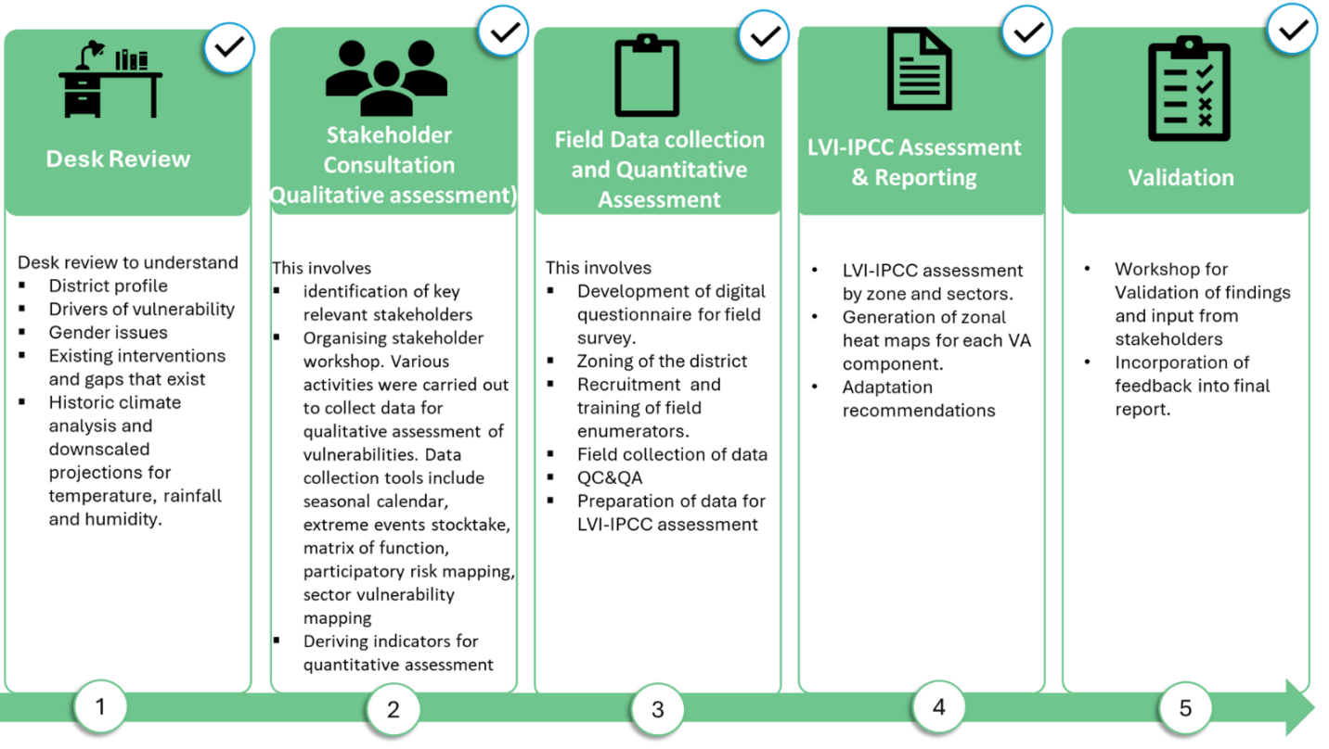
Figure 1: The Vulnerability Assessment Process

Data Collection
The VA combined both qualitative and quantitative approaches. Qualitative assessment draws on local knowledge from communities and stakeholders, as well as statistical and geospatial data, to build a comprehensive picture of how climate change is currently affecting different sectors and social groups. It captures insights, perceptions, and experiences of community members and stakeholders that cannot be fully reflected through numbers alone.
Complementary, quantitative assessment introduces a numerical framework that allows for the pragmatic comparison of vulnerability levels across different geographic areas, population groups, or components of the human environment within and across communities. It relies on the understanding of the vulnerability components (exposure, sensitivity, adaptive capacity) during the qualitative assessment to derive indicators which questionnaires are used to get a real field data to measure, analyse and compare vulnerabilities.
Data for qualitative was collected through:
- Desktop review: The review aimed to understand what information existed and where there were gaps. The initial desk review provided a good stocktake of climate and vulnerability data in the Ada East District Assembly. The outcome of the desk review was used to engage and obtain more information through the stakeholder consultation processes.
- Stakeholders and experts’ consultation: When relevant, experts at the national, regional, district, and local levels were consulted to collect data and input, and to verify information.
- Stakeholder engagement workshop: The stakeholder workshop was used to both collect data on prevailing climate change, impacts, and vulnerabilities, while the validation workshop was used to validate the final vulnerability assessment report.
- Various activities were carried out to collect data for qualitative assessment of vulnerabilities. Data collection tools include seasonal calendar (focused on the primary everyday activities of the district and how they are impacted by current climate variaions and change), extreme events stocktake (capturing climate related events such as floods, droughts, forest fires, etc) , matrix of function (assessing the availability of basic amenities that are needed for daily functioning of the community), participatory risk mapping (identifying and mapping hotspots, people and assets), sector vulnerability mapping (prioritising impacts on sectors)
The locations constituted four zonal councils in the districts; while the sectors were agriculture (crop, fishery and livestock), forests (biodiversity and ecosystems), water, health and sanitation, infrastructure and transportation, services, and trade and finance (Commence).
Data for quantitative was collected through:
- Community-based survey: Digital questionnaires were derived based on the variable for each indicator and administered to a predetermined sample size number of households in each of the 12 vulnerable communities. In total, 420 households were interviewed. Enumerators (primarily staff from the Ada East District Assembly) were trained to visit the communities and interview households for the information needed. Data from the community-based survey is used to conduct the quantitative LVI-IPCC assessment for the district and sectors.

Assessing Current and Future Climate Analysis
Current climate. Daily rainfall from CHIRPS and air temperature/relative humidity from ERA5 are clipped to the Ada East district boundary. Using the 1991–2020 baseline, standard indices are derived heavy-rain days (R10/R20), 1-day and 5-day maxima (Rx1/Rx5), wet/dry-spell length (CWD/CDD), rain-day intensity (SDII), hot/cool days and nights (TX90p/TX10p; TN90p/TN10p), and diurnal temperature range. Monthly climatologies are produced to reflect Ada East’s bimodal rainfall regime.
Future climate. Projections draw on a CMIP6 multi-model ensemble under SSP2-4.5 and SSP5-8.5, summarised for 2026–2050, 2051–2075, and 2076–2100. Each model is spatially averaged over the district; results are reported as ensemble means with spread. Emphasis is on changes in heavy-rain intensity (flood risk) and hot days/nights (heat-health), with a qualitative sea-level-rise context for coastal cells.

CHAPTER 2 - DISTRICT PROFILE
This chapter outlines the background of Ada East District to provide context for its climate vulnerability. It highlights the district’s demographic characteristics, geographical and environmental features, including its coastal attributes, administration and governance and economic overview, as these combined factors shape the district’s exposure, sensitivity and adaptive capacity to current and future climate risks of Ada East district.

2.1 Location and size
Ada East District is a district in Ghana's Greater Accra Region, originally part of the larger Dangme East District. It was renamed Ada East District after the western part was split off to create Ada West District in 2012. The Ada East District is situated in the southeastern part of the Greater Accra Region, covering approximately 290 km² and has Ada Foah as its capital town. The district covers an area of 289.783 square kilometre and is located within latitude 5°45 and 6°00 (North) and Longitudes 0°20 to 0°35 (East).
Ada East District is bordered by Central Tongu to the north, South Tongu to the east, Ada West to the west and the Gulf of Guinea to the south, where 19 km of coastline stretch from Kewunor to Totope (Ministry of Local Government and Rural Development, 2020). To the southeast, the Volta River flows into the Gulf of Guinea, creating an estuary near the district capital, Ada-Foah and making it a vital natural resource for fishing, transport and irrigation (Ghana Fisheries Authority, 2019). Major settlements include Big Ada, Kasseh, Totimekope, Ocanseykope and Pute.
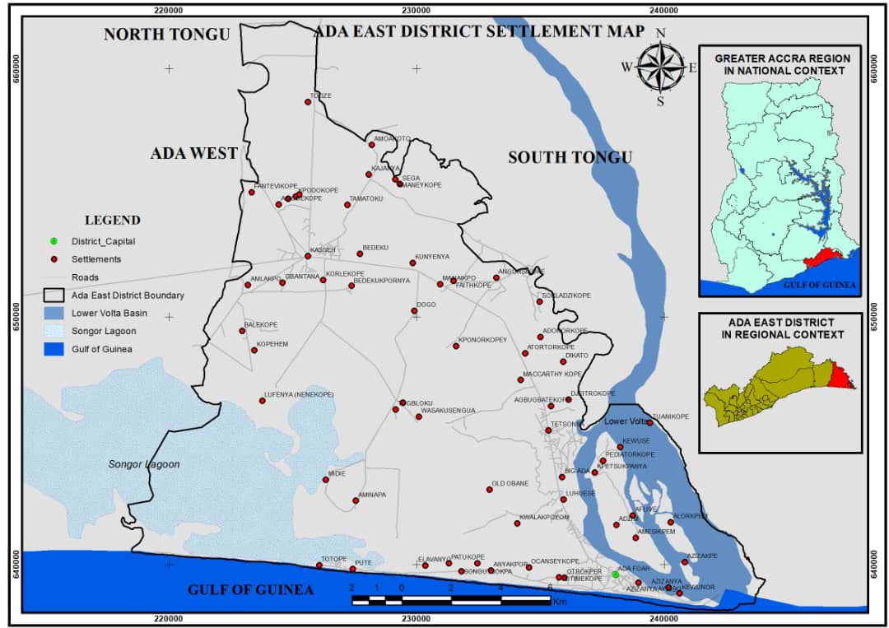
Figure 2: Map of Ada East District (Source: Ghana Statistical Service, GIS)

2.2 Demographic overview
The district has a population of 71,671, accounting for 1.8% of the Greater Accra Region's total population according to the 2016 population and housing census (GSS, 2016.). The district has a youthful population, with over half (54%) under 15 and a high age dependency ratio, particularly among males. Ada East reports one of the highest fertility rates in the region, with 103.4 births per 1,000 women aged 15–49. Migration is also notable, as more than half of the district's migrants were born in other regions of Ghana.

Figure 3: Age Distribution of Population In Ada East Dstrict
Source: Ghana Statistical Service

In terms of household structure, the district comprises 15,631 households with an average household size of 4.6 people. Children make up the largest share of household members and nuclear families account for about 20% of all households. The district has a diverse and active population, with 75% of those aged 15 and older being economically active.
Among those employed, 20.2% work in agriculture, forestry and fishing; 39.3% are in service and sales; 23.3% are in crafts and trades; and 6.8% are professionals, managers, or technicians. The private informal sector dominates employment, accounting for 92.2%, followed by the public sector at 4.4%. Access to information and communication technology is widespread, with a majority of the population owning mobile phones, though men are more likely to own them (50.3%). The district also reports a significant population of persons with disabilities, with women representing 4.8% of this group. Unfortunately, most disabled individuals have never attended school and ICT ownership remains largely male dominated

2.3 Administration and governance
The Ada East District Assembly serves as the highest political and administrative authority within the district. It is led by a District Chief Executive (DCE), who acts as the political head and is supported administratively by the District Coordinating Director, the chief advisor to the DCE. The Assembly exercises legislative, deliberative and executive functions as mandated by the Local Government Act of 1993. Administratively, the district is organized into three area councils—Ada-Foah, Big Ada and Kasseh—encompassing the thirty-seven (37) electoral areas. The General Assembly, presided over by a Presiding Member elected from among the Assembly members, functions as the highest decision-making body in the district.
The Assembly is composed of thirty-nine (39) members, including the DCE and the Member of Parliament for Ada East Constituency. Of the remaining thirty-seven (37) members, ten (10) are government appointees and twenty-seven (27) are elected representatives. Notably, only four (4) of the thirty-seven members are women, representing approximately 10% of the Assembly. Further, there are eleven (11) decentralized departments within the district, each responsible for implementing sector-specific policies and development programs. These departments collaborate with local stakeholders and partner institutions to advance the district's development agenda and improve the well-being of its residents.

2.4 Physical and environmental features
Geographically, the district’s position between the Gulf of Guinea and the Volta River provides fertile grounds for fishing and agriculture, which dominate local livelihoods. Fishing and fish processing are the mainstay industries, supported by abundant marine and riverine resources. Agricultural production, especially maize, cassava and plantain, also contributes to the local economy. However, the proximity to the coast exposes infrastructure to corrosion from salty sea air, resulting in frequent maintenance challenges.
Vegetation in the district is diverse, comprising coastal savanna, mangrove forests and coconut groves. The savanna provides extensive grazing for over 5,000 cattle herds, though unmanaged grazing near water bodies often contaminates streams, limiting safe water availability. To mitigate this, the 3-District Water Supply Scheme has improved potable water access for several communities. Mangroves, especially along tributaries of the Volta River, stabilize ecosystems but are less extensive than other vegetation types. Coconut trees enhance coastal scenery while salt pans benefit from the high evaporation rates that support the local salt industry.
Climatically, Ada East experiences average annual temperatures of 23–28°C, with peaks of 33°C during heatwaves. Rainfall is seasonal, with heavy rains between March and September averaging 750 mm, while the harmattan season (November to March) brings long dry spells. Relative humidity averages 60% and daily evaporation ranges from 5.4 to 6.8 mm. These variations affect agriculture and water supply, making them vulnerable sectors. However, the district’s high solar radiation presents opportunities for renewable energy, though uptake remains limited.
The district’s natural environment also provides avenues for eco-tourism. The Volta River estuary supports rich biodiversity, including numerous bird species, making it a prime bird-watching destination. Scenic coastal landscapes, mangrove ecosystems and diverse flora enhance its tourism potential. At the same time, challenges such as coastal erosion, salt corrosion of infrastructure, water contamination and climate variability threaten livelihoods and natural systems.

2.5 Economic overview (major economic sectors vulnerability to climate change)
The economy of Ada East District is largely agrarian, with crop farming, fishing and salt mining forming the backbone of livelihoods and local development. These sectors employ the majority of the labour force, sustain food security and drive household incomes and trade. Agriculture employs more than 60% of the working population, dominated by smallholder farmers engaged in rain-fed cultivation of cassava, maize, rice and vegetables (GSS, 2021). Livestock rearing, including poultry, goats and cattle, supplements crop farming and provides additional income for rural households.
Fishing is the second most important sector, supported by the Volta River, estuary and the Gulf of Guinea. Both inland and marine fisheries are practiced, with thousands of residents depending on fishing for employment and nutrition. Women play a critical role in fish processing and trading, making the sector vital not only to food systems but also to gendered livelihoods (MoFAD, 2020). Salt mining, concentrated around the Songor Lagoon, is another significant economic activity. Traditional salt extraction methods remain common, but the industry is recognized for its potential to expand into industrial production and export markets.
Commerce and services also complement the primary sectors. Kasseh, the largest market center and Big Ada, serve as a commercial hubs for traders across the Greater Accra Region, providing outlets for fish, farm produce, textiles and consumer goods. Small and medium-sized enterprises including petty traders, artisans, food vendors and transport operators, anchor the informal economy (MLGDRD, 2022). Tourism is also emerging as a sector of promise, with attractions such as the Ada Foah estuary, the Asafotufiami festival and coastal resorts drawing interest in eco-tourism, and cultural heritage tourism. Deeping the diversity of the district’s economy.
Despite these endowments, Ada East faces persistent economic vulnerabilities. Agriculture remains highly dependent on seasonal rainfall, leaving farmers exposed to prolonged dry spells and soil salinization, particularly around the Songor Lagoon (Tarolli et al., 2024; Osman, 2023). These conditions reduce yields of cassava, maize and vegetables, threatening both household income and food security. Fisheries are similarly at risk from changing rainfall patterns, seawater intrusion and irregular fish stocks that disrupt traditional fishing cycles (Townhill et al., 2023; Mohd et al., 2024). In addition, salt production is constrained by ecological pressures, with saltwater intrusion into freshwater systems affecting productivity (Krair, 2020).
These climate impacts are compounded by structural barriers. Limited access to insurance, credit and agricultural inputs prevents farmers and fisherfolk from adopting resilient practices. Informal employment dominates the economy, leaving many women and youth vulnerable to shocks without adequate social protection (Dodman et al., 2023). Infrastructure deficits such as poor storage facilities, inadequate roads and unreliable energy access, further constrain productivity, market access and value addition. Youth unemployment remains high, reflecting limited opportunities beyond agriculture and petty trading.
Overall, while Ada East’s economy is anchored in natural resource–based activities that provide livelihoods for most households, its vulnerability to climate variability, ecological degradation and structural challenges undermines long-term sustainability. Addressing these issues will require inclusive economic planning, stronger public-private partnerships and deliberate investment in climate-resilient livelihoods, market systems and social protection to safeguard the district’s economic future.

CHAPTER 3 – ASSESSMENT OF VULNERABILITY TO CURRENT CLIMATE CHANGE
This chapter describes level of vulnerability for Ada East District including its communities observed climatic characteristics, economic sectors and corresponding underlying factors such as observed climatic changes including hazards, factors of vulnerability to identify vulnerable locations, sectors and groups and climate change impacts on vulnerable locations, sectors and groups

3.1 Analysis of the Observed Climate Changes
This section presents the observed climatic characteristics of Ada East District.

3.1.1 Rainfall Characteristics
- Historical rainfall pattern: Ada East experiences a bimodal rainfall regime, with major rains in May–June and minor rains in September–October.
- Observed trends: Historical data show higher totals of annual and extreme rainfall compared to projected future scenarios (SSP2-4.5 and SSP5-8.5).
- Indices such as total annual rainfall (RR) and extreme precipitation days (R95p, R95pTOT) were higher in the historical baseline than under future projections.
- Increase in dry spells: Prolonged dry days (DD) and consecutive dry days (CDD) are expected to rise, signaling longer drought periods.
- Decline in wet spells: The frequency of wet days (WD) and consecutive wet days (CWD) is projected to fall, intensifying rainfall variability.
- Fewer but more intense rainfall events are likely, increasing risks of flash floods, soil erosion, and reduced predictability for rain-fed agriculture (Ghana Meteorological Agency 2020; EPA 2021).

3.1.2 Temperature Characteristics
- Rising Temperatures: Average temperatures in Ada East have increased by 1.0°C–1.5°C over the past five decades (GMet, 2020), consistent with broader West African warming of ~0.2°C per decade since the 1960s (IPCC, 2021).
- Current Range: Daytime temperatures now range between 27°C and 33°C, with peaks above 35°C during the hot season (February–April) (EPA, 2021).

- Heatwaves & Soil Stress: Rising heat intensity has led to more frequent heatwaves, higher evaporation rates, and reduced soil moisture retention.
- Agricultural Impacts: Farmers report significant heat stress on crops such as maize and okra, resulting in lower yields and reduced income (MoFA, 2023).
- Water Security: Increased evaporation contributes to declining water availability, exacerbating household and farming challenges.
- Health Risks: Prolonged exposure to high temperatures has been linked to rising cases of heat exhaustion, dehydration, and related health issues, especially among children and the elderly (MoH, 2020).

3.1.3 Tidal and Coastal Dynamics
- Sea Level Rise: Along the Gulf of Guinea, sea levels are rising at an average of 3.1 mm per year, exposing Ada East’s coastal communities to higher risks (Appeaning Addo et al., 2011; IPCC, 2021).
- Accelerated Coastal Erosion: Communities such as Azizanya, Kewunor, and Ada Foah are losing several meters of shoreline annually, undermining settlements and infrastructure (Boateng, 2012).
- Saltwater Intrusion: Rising seas are driving saltwater intrusion into freshwater aquifers and farmlands, contaminating drinking water sources (WRI, 2022).
- Agricultural Threats: Intrusion of saltwater into soils is reducing farmland productivity, making some areas unsuitable for crop cultivation.
- Livelihood Risks: These combined pressures of land loss and water contamination threaten Ada East’s agrarian and fishing-based economy, putting vulnerable households at greater risk.

3.1.4. District Seasonal Change Calendar
The climate-induced seasonal calendar of Ada East was participatorily developed by stakeholders combining expert insights with lived experiences of the district. Stakeholders observed that the seasonal calendar has been shifting under the influence of climate change, disrupting planting, harvesting, fishing cycles, and reshaping social roles and responsibilities.
- Agriculture remains the backbone of livelihoods. Key crops such as maize, melon, and vegetables follow distinct seasonal cycles. Traditionally, maize is planted in January and October, while melons are planted in February and August. Vegetables, a major source of household income, are cultivated almost year-round, with peaks in planting in January and harvesting in December. However, climate change has disrupted these patterns. Erratic rainfall delays planting, while prolonged dry spells force farmers into staggered schedules. Many now rely on supplementary irrigation, though access varies depending on resources. Women play a significant role in planting and harvesting, often as hired laborers during peak seasons, making them especially vulnerable to climate-induced agricultural disruptions.
- Fishing is another critical livelihood and remains highly seasonal. Men dominate marine fishing expeditions, which intensify during the dry season when sea conditions are more favorable. Women, by contrast, are primarily engaged in processing and trading fish, transforming fresh catch into smoked or dried products for sale. Yet, changing tidal regimes, declining fish stocks, and sea level rise have altered the timing and productivity of fishing seasons. Women are excluded from decision-making on when expeditions are launched, despite their heavy reliance on the outcomes. This exclusion worsens gender disparities and undermines household resilience.
- Salt mining a traditional activity, peaks in the hot and dry months (December–February) when evaporation is highest. Men are mainly responsible for mining salt, while women dominate processing and trade. Climate variability introduces unpredictability: unseasonal rains often flood salt pans, reducing yields and causing financial losses. This disproportionately impacts women traders whose incomes depend on timely access to processed salt.
- Livestock rearing (especially cattle) occurs year-round but becomes more demanding in the dry season when grazing land is scarce. Men and boys typically shoulder the responsibility of moving animals long distances in search of fodder and water, while women contribute indirectly by managing household food during lean periods. Prolonged droughts increase livestock mortality, eroding a critical safety net for households.
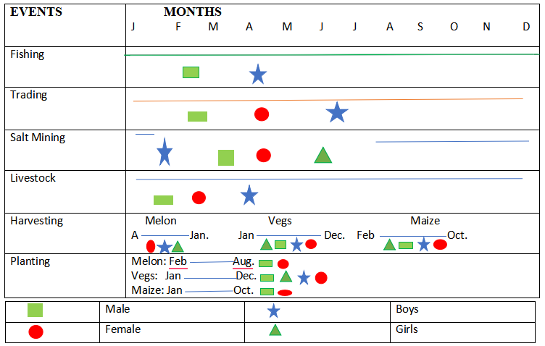
Dec
April
April
Figure 4: Digitalised image of stakeholder (group) representation of district seasonal calendar

The gendered nature of seasonal labor in Ada East is striking. Men often control the timing of fishing, livestock movements, and salt mining, while women shoulder much of the burden of planting, harvesting, fish processing, and trading. Women’s peak labor demands occur during planting and harvesting seasons, when they provide both family and hired labor. At these times, their workload increases significantly, reducing time for domestic responsibilities and limiting opportunities for other income-generating activities. Children—particularly girls—are sometimes withdrawn from school to assist with farm work or trading during peak periods. Persons with disabilities (PWDs) and other marginalized groups face heightened vulnerability, as discrimination and social barriers often exclude them from agricultural and fishing labor opportunities, leaving them with very limited income options.
Over the last 20–30 years, the timing of seasonal activities has shifted considerably. Previously, predictable rainfall allowed for timely land preparation and planting. Today, climate variability has delayed planting windows, shortened growing periods, and increased risks of crop failure. Fishing yields, once abundant during specific months, are declining, while tidal surges and coastal erosion now threaten aquaculture and fish-processing facilities. These changes have contributed to food insecurity, income losses, and increased migration of youth to urban areas in search of alternative livelihoods.
In response, households and communities have adopted a variety of coping strategies. Farmers increasingly rely on supplementary irrigation, though access remains limited to wealthier households. Women traders and processors are diversifying into petty trading and non-farm activities to cushion losses. Some communities are pursuing afforestation and mangrove restoration initiatives to safeguard coastlines and water bodies. Meanwhile, early warning systems are gaining recognition as essential tools for managing risks, but dissemination remains weak. Strengthening climate information services to provide timely and accessible forecasts for farmers and fishers would greatly enhance adaptive capacity in the district.

3.2 Qualitative Assessment of Vulnerability to Current Climate Change
This section presents an assessment of the vulnerability of Ada East summarised from the responses of stakeholders’ in a District-Specific Vulnerability Assessment Validation of Adaptation Strategies Workshop workshop organised on April 29th, 2025 in Ada East district. The workshop brought together 33 participants from relevant sectors of the district. The stakeholders/participants include officers of the municipalities, representatives of government agencies relevant to climate impacts, traditional authority and community groups, representative of persons living with disability, non-governmental and corporate social organisations and the media.
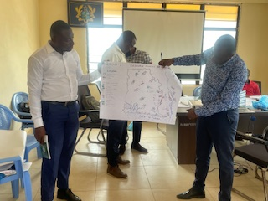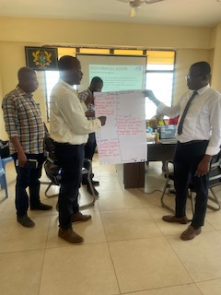
Figure 5: Images of Stakeholders at District-Specific Vulnerability Assessment Validation of Adaptation Strategies Workshop workshop organised on April 29th, 2025

3.2.1 Extreme Event Records in the district
Ada East District’s geography, climate variability, and human activity have combined to make it highly susceptible to a range of climate hazards that have intensified over time.
Coastal flooding is among the most recurrent and damaging hazards. The district’s low-lying position between the Volta River and the Atlantic Ocean exposes it to flooding from tidal surges, river overflows, and intense rainfall. Records from the National Disaster Management Organization indicate that flood events in coastal Ghana—particularly in Ada East—have become more frequent and severe over the past two decades. The controlled spillage of the Akosombo Dam in September 2023 illustrates how climate variability interacts with human interventions to produce cascading risks. While the spillage was necessary to safeguard the dam’s integrity, it inundated vast areas of Ada East, displacing over 5,600 people, destroying more than 2,000 homes, and submerging croplands. Just months later, in April 2024, tidal surges combined with high river levels submerged over 100 structures in communities such as Azizanya, Ayigbo, and Kewunor. These overlapping events underscore how multiple hazards can converge to magnify local vulnerabilities. The situation is worsened by inadequate drainage, weak land-use planning, and unregulated construction in flood-prone zones, leaving more than 30 percent of settlements exposed to high flood risks. Climate projections of more extreme rainfall further highlight the precarious future facing the district.
Tidal waves and coastal erosion compound these challenges. Locally described as “sea defense breaches,” tidal waves have grown more frequent and destructive, displacing households, destroying homes, and washing away farmland. In April 2022, powerful waves devastated Kewunor in Ada East district and Fuveme in the Volta Region, demolishing over 300 homes and stripping away large tracts of farmland. The absence of a continuous sea defense system leaves many communities vulnerable to relentless wave action. Beyond physical losses, tidal waves exacerbate saltwater intrusion into freshwater and farmland, undermining both food and water security. Human activities such as sand mining, destruction of coastal vegetation, and unregulated construction further weaken natural defenses. Between 2005 and 2020, Ada East lost over 120 hectares of coastal land—a stark reminder of its shrinking shoreline.
Equally concerning is the decline of mangrove ecosystems, which serve as natural buffers against floods and erosion while providing vital breeding grounds for fish and crabs. In Ada East, mangroves in the Songor Lagoon and Volta River estuary have been severely degraded by unsustainable harvesting for firewood, fish smoking, and urban expansion, compounded by climate stressors such as salinity changes and sea level rise. The consequences are already visible: dwindling crab and fish stocks are eroding household incomes, while communities lose crucial protection against tidal surges. Evidence from other coastal regions suggests that community-led mangrove restoration, supported by legal protection and alternative livelihoods, could enhance both ecological and economic resilience.
The district also faces mounting climate-related health risks. Flooding creates stagnant water that breeds mosquitoes and fosters outbreaks of malaria, cholera, typhoid, and hepatitis A. In October 2024, Ada East and Ada West recorded 43 confirmed cholera cases, including two fatalities. A wider outbreak in March 2025 affected more than 1,700 individuals across 32 districts, with Ada East among the hardest hit. These outbreaks were linked to flood-induced contamination of water supplies, inadequate drainage, and indiscriminate waste disposal. Settlements such as Ada Foah and Kasseh, which rely heavily on open drains, are especially vulnerable. Rising temperatures also accelerate mosquito life cycles, extending malaria transmission seasons and widening the spread of vector-borne diseases. Local clinics, already overstretched, struggle to respond—underscoring the urgent need for stronger disease surveillance, improved WASH infrastructure, and targeted health education.
The historical record reveals a clear escalation in both the frequency and severity of climate hazards in Ada East, shaped as much by human activity and weak infrastructure as by climatic forces.
Table 1: Observed Natural Hazard and Extreme Events in Ada East District
Date | Hazardous Event | Location | Impact | Reference
Jan-2024 | Fire Outbreak | Koluedor zongo, Tojeh, Hwakpo and Addo Kope in the Ada East District | It causes damage to property animals and in the case of ECG, some wooden electricity poles in the bushy areas. | https://www.graphic.com.gh/news/general-news/ghana-news-see-how-bushfires-are-destroying-ecg-power-poles-in-tema-area-photos.html
Oct-2024 | Cholera Outbreak | Ada East and Ada West districts in the Greater Accra | It resulted in the deaths of two individual with 43 cases reported | https://www.myjoyonline.com/cholera-outbreak-claims-two-lives-in-ada
Apr-2024 | Flood | Azizanya ,Kewunor,, Ayiboe in Ada East | Over 100 structures being submerged and properties destroyed | https://gna.org.gh/2024/04/river-waves-flood-three-communities-in-ada/
Jun-2015 | Flood | Some part of Greater Accra Region with Ada East | The floods resulted in the displacement of community populations, loss of over 200 lives and loss of properties and livelihoods | https://relief web.int/report/ghana/ghana-floods-emergency-plan-action-epoa-mdrgh011
Jan-2022 | Drought | Ada East of the Greater Accra | It affected most food producers which also threaten food security | https://www.businessghana.com/site/news/general/254201/Unpredictable-climatic-conditions-affect-crop-yield-at-Ada
Apr-2024 | Flood | Dangme East District in Ada of the Greater Accra region | The flood causes home and other properties destroyed | https://citinewsroom.com/2024/04/homes-submerged-as-floodwaters-inundate-ada/
Oct-2023 | Flood | Ada East Community | leading to the displacement of many families, the destruction of farmlands and a complete upheaval in the daily routines of these individuals. | https://www.classfmonline.com/news/Dam-spillage-Queen-Mother-calls-for-help-for-affected-communities-at-Ada-46488
Oct-2024 | Disease Outbreak | Kasseh – Ada of the Ada East | 43 persons have been confirmed to have cholera out of which 2 death were recorded. | https://gna.org.gh/2024/10/cholera-outbreak-ada-residents-at-risk-as-disease-spreads/
Apr-2022 | Tidal waves and coastal erosion, | Ada East in the Greater Accra Region | Tidal waves have destroyed homes, leaving many residents homeless. Properties, including houses and farmlands, have been washed away, causing business losses and severe economic hardship for affected families. | https://www.ghanabusinessnews.com/2022/04/15/uncompleted-sea-defence-wall-rendering-us-homeless-ada-east-residents/
Oct-2023 | Flood | Ada East | Approximately 5,685 individuals and 1,135 households affected across 28 communities; displacement of residents; destruction of farms; damage to schools and health facilities. | https://www.myjoyonline.com/about-5685-people-were-affected-by-akosombo-dam-spillage-in-ada-nadmo/
Jun-2024 | Mangrove Depletion | Ada East District | Significant decline of mangrove forests due to urbanization, over exploitation, pollution, wildfires and climate change; loss of coastal protection and biodiversity. | https://www.ghanaweb.com/GhanaHomePage/NewsArchive/Green-Ghana-Day-NGO-partners-move-to-restore-depleted-mangroves-in-Ada
Mar-2023 | Boat Disaster | Azizakpe, Ada East District | passengers were traveling to Azizakpe for a funeral when their boat capsized due to strong winds; none were wearing life jackets and the boat was allegedly overloaded. | https://www.graphic.com.gh/news/general-news/ada-boat-disaster.html
Feb-2022 | Cosatal Erosion | Agorkedzi in Ada East | Displacement of residents, destruction of property and appeals for government intervention to build sea defenses | https://lensational.org/photo-stories/home-is-now-far-away-the-disappearing-coast-of-agorkedzi/
Jun-2018 | Coastal Erosin | Ada Foah | Risk of the church being destroyed by the encroaching sea. | https://noahdamehblog.wordpress.com/2018/10/06/the-bethel-presbyterian-church-at-ada-foah-stands-at-a-risk/
Dec-2023 | Flooding | Ada East, Central Tongu, North Tongu,Shai ,Osuduku | Destroying homes and farmlands along the banks of the river Volta | https://dtm.iom.int/node/32451
Mar-2025 | Disease Outbreak | Ada District of the Greater Accra Region | there were 1,726 suspected cases in 32 districts, of which 131 have been confirmed and 16 deaths have been reported. Most cases are concentrated in the Greater Accra region, with 68 confirmed cases. | https://ghana.un.org/en/290662-ghana-%E2%80%94-population-mobility-mapping-rapid-cholera-response-february-2025
Jan-2022 | Flood | Azizakpey is situated on an island surrounded by the Volta River in the Ada East District of the Greater Accra Region | Floodwaters have damaged or destroyed numerous houses, forcing residents to salvage materials like aluminum roofing sheets to rebuild | https://lensational.org/photo-stories/waking-up-to-water-in-azizakpey/
Oct-2023 | Aggressive Sea - Waves | Ada and Keta in Ghana | disrupting ecosystems worldwide due to negative human activities resulting in heat waves | https://thefourthestategh.com/2023/10/climate-change-beware-sea-washing-away-keta-ada-lets-explore-what-we-can-do/

3.2.2 Assessment of Drivers of Vulnerability in the District
The Stakeholder workshop formed groups based on participants experience (working and lived). The groups were tasked to map out physical/resource, identify hazard risk areas and present the main climate hazards and their impacts in the district, how people in the district currently adapt with the impacts of the specific hazards identified and the perceived effectiveness of the adaptation strategies

3.2.3 Assessing Climate Change Hazards and Their Associated Impacts on Associated Impacts on Vulnerable Locations, Sectors and Groups

3.2.3.1 Hazards and associated impacts on vulnerable locations
The groups were tasked to map out physical/resource, identify hazard risk areas and present the main climate hazards and their impacts in the district, how people in the district currently adapt with the impacts of the specific hazards identified and the perceived effectiveness of the adaptation strategies. The assessment identified several communities within Ada East District as highly vulnerable to environmental hazards, underscoring the urgent need for targeted interventions that integrate gender-sensitive solutions and address the specific needs of children, women and other marginalized groups. Identified vulnerable areas include:
Flood-Prone Zones
- Coastal and island communities such as Luhuese, Ayigbo, Kasseh, Atortorkope, Lolonyakope and Azizanya experience recurrent flooding due to their low-lying and wetland nature.
- Other exposed communities, including Elavanyo, also face recurring flood events triggered by river overflows and poor drainage systems, which disrupt livelihoods and damage households.
- Flooding events often deprive children of education, as schools are closed or destroyed and also create outbreaks of waterborne diseases like cholera.
Sea Erosion and Tidal Flooding
- Coastal areas such as Azizanya and Kewunor are severely impacted by sea erosion, which leads to the destruction of property and displacements.
- Rising sea levels have accelerated saltwater intrusion into freshwater systems, affecting both drinking water sources and agricultural lands.
- These hazards directly threaten livelihoods dependent on fishing and farming, with men often losing boats and nets, while women suffer losses in fish processing and marketing activities.
Drought-Prone Areas
- Some communities in Ada East are increasingly affected by drought conditions, with erratic rainfall patterns causing prolonged dry spells.
- The impacts of drought are particularly severe for women, who bear the responsibility of fetching water and managing household food supplies, compounding their vulnerability and workload.
- Farmers face declining yields due to inadequate irrigation systems, while livestock herders struggle with limited pasture and water.
Key Landmarks and Community Resources
The assessment also highlighted critical infrastructure and community resources within Ada East District that are vulnerable to climate and environmental hazards, emphasizing the need for climate-resilient planning and protection measures.
Water Infrastructure
- Water resources, including rivers, wells and rainwater harvesting systems, remain critical for survival but are increasingly threatened by both floods and droughts.
- Safe shelter havens and accommodation facilities for displaced households are managed mainly by the District Assembly and NADMO, but they are often inadequate during major flood events.
Tourism and Recreation
- The Songor Lagoon and adjoining estuarine systems represent significant ecological and recreational landmarks but are under severe threat from tidal flooding, sea intrusion and unregulated exploitation of natural resources.
- The decline of mangroves in these areas has reduced their protective capacity, further endangering both biodiversity and livelihoods.
Educational Institutions
- Schools located in low-lying and flood-prone communities are highly vulnerable to climate events, which disrupt academic calendars and deprive children of consistent education.
- These impacts extend beyond structural damage to psychosocial stress on children, particularly during prolonged displacements.
Healthcare Facilities
- Community health facilities, including CHPS compounds and clinics, are critical for service delivery but become overstretched during disease outbreaks linked to flooding and poor sanitation.
- The spread of cholera and malaria after flood events highlights the urgency of integrating health resilience into disaster management planning.
- Social and Security Infrastructure
- Churches, mosques and community centers serve as key social cohesion points but are equally vulnerable to floods and sea erosion in low-lying zones.
- The district has limited disaster evacuation points and weak institutional presence for immediate response, compounding the risks during emergencies.
Agricultural and Fishing Lands
- Farmlands located in wetland areas are continually threatened by floods and salinity, jeopardizing the cultivation of staple crops such as maize and vegetables.
- Fishing grounds are also at risk from sea erosion and tidal flooding, undermining the district’s coastal economy. Women engaged in processing and trading are disproportionately affected, as their income sources collapse during hazard event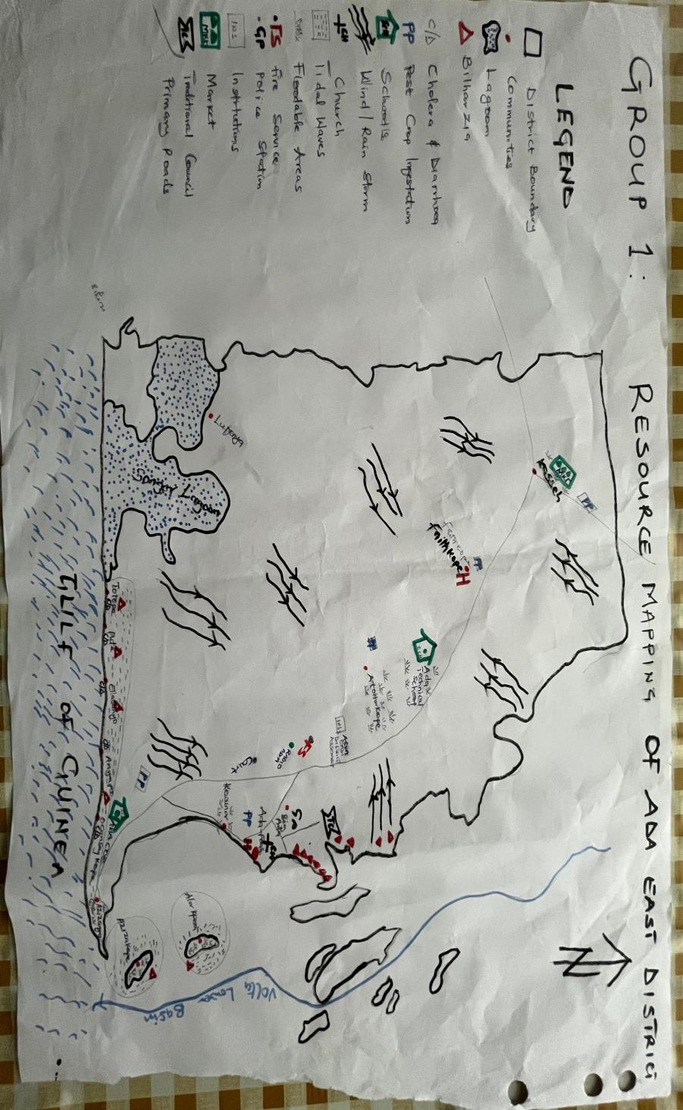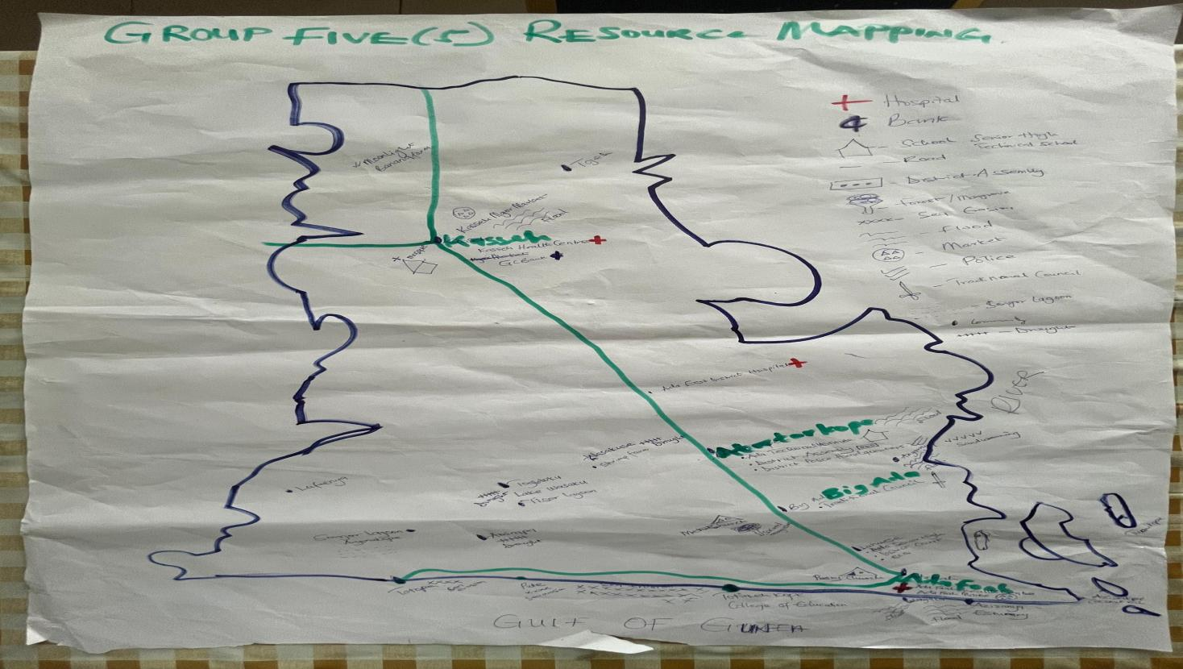
Figure 6: Visualisations of critical infrastructure, key resources and vulnerable areas, Ada East District
Source: Stakeholder Validation Worshop group work

3.2.3.2 Hazards and associated impacts on vulnerable sectors
The economy of Ada East District is anchored in agriculture, fisheries and aquaculture, salt mining, petty trading, and services, which together form the backbone of local livelihoods.
Agriculture remains dominant, with maize, vegetables, and melon as key crops. However, production is increasingly constrained by rainfall variability, prolonged dry spells, and soil salinity. These challenges not only reduce yields but also undermine household food security and incomes.
Fisheries and aquaculture sustain a large proportion of artisanal fishers and fish processors, particularly women. Yet tidal surges, flooding, and coastal erosion are steadily eroding landing sites and fish habitats, driving down productivity.
Water resources are under growing stress. Saltwater intrusion into freshwater aquifers and surface water bodies has compounded problems of scarcity during dry seasons. Poor drainage and weak water management infrastructure further heighten the risks of contamination and unreliability of supplies, leaving many households dependent on costly purchased water.
Health and sanitation are particularly vulnerable to climate hazards. Floods leave stagnant water that fosters mosquito breeding and increases malaria transmission. Poor drainage worsens outbreaks of cholera and other waterborne diseases, often overwhelming local health facilities, as seen in recent flood-related cholera outbreaks.
Forestry and aquatic biodiversity are in decline, with mangroves in the Songor Lagoon and Volta estuary significantly degraded by overharvesting, urban expansion, and sea level rise. Their loss has reduced natural defenses against erosion, diminished carbon sequestration, and weakened fish and crab breeding grounds—undermining both ecological integrity and community livelihoods.
Disaster risk reduction has become a district priority, but gaps in infrastructure such as storm drains, evacuation points, and sea defense systems leave communities like Azizanya, Kewunor, and Ada Foah highly exposed to recurrent hazards. Weak institutional coordination further constrains timely response, underscoring the need for stronger preparedness and community-based early warning systems.
Gender dynamics compound vulnerability. Women are central to farming, fish processing, and trading, but are often excluded from decision-making in agricultural and fisheries governance. This exclusion limits their adaptive capacity, even as they bear disproportionate burdens during planting, harvesting, and processing seasons. Their reliance on degraded ecosystems heightens exposure to income shocks, while heavy workloads during climate-related crises constrain opportunities for diversification.
Tourism is emerging as a potential driver of economic diversification, with beaches and the Songor Lagoon offering attractive natural assets. However, erosion, flooding, and poor road infrastructure undermine accessibility and reduce its long-term viability as a sustainable sector. Without climate-resilient infrastructure and ecosystem restoration, its potential will remain underexploited.
To prioritize interventions, the district applied the Simple Weighted Average Rank (SWAR) method, which calculates the average ranking position of each sector weighted by frequency. In this method, a lower average position indicates a higher priority or stronger climate impact (see Table 2). The results show:
- Agriculture ranks first, with the lowest weighted average position (2.2), highlighting its status as the most climate-sensitive sector.
- Water resources ranks second (2.25), reflecting its consistent prioritization across groups due to challenges such as saline intrusion and scarcity.
- Fisheries and aquaculture is third (2.4), closely following, emphasizing its importance to coastal livelihoods and vulnerability to tidal surges.
- Disaster Risk Reduction ranks fourth (3.3), indicating recognition of increasing hazard management needs, though it received fewer top rankings.
- Health and sanitation ranks fifth (3.8), demonstrating notable concern, but typically ranked below sectors more directly linked to livelihoods and ecosystems.
Table 2: Ranking of the most important and vulnerable economic sectors to climate cange
Sector | Position/Frequency |  |  |  |  |  |  |  | Rank
Sector | 1 | 2 | 3 | 4 | 5 | 6 | 7 | 8 | Rank
1. Agriculture | 15 | 3 | 1 | 0 | 0 | 0 | 0 | 0 | 1st
2. Fisheries and acquaculture | 3 | 4 | 2 | 2 | 3 | 6 | 0 | 1 | 3rd
3. Water resources | 1 | 6 | 4 | 6 | 1 | 1 | 0 | 0 | 2nd
4. Health and sanitation | 2 | 4 | 6 | 1 | 2 | 4 | 0 | 2 | 5th
5. Forestry and Acquatic Biodiversity | 0 | 0 | 2 | 3 | 5 | 3 | 6 | 0 | 6th
6. Disaster Risk Reduction | 0 | 1 | 3 | 3 | 3 | 3 | 2 | 5 | 4th
7. Gender | 0 | 3 | 2 | 3 | 4 | 2 | 4 | 2 | 7th
8. Tourism | 0 | 0 | 0 | 0 | 0 | 1 | 7 | 12 | 8th

3.2.3.3 Hazards and associated impacts on vulnerable groups (with focus on gender specific impacts)
Using information generated from stakeholder group presentations on the impacts of climate hazards on vulnerable populations, the study finds that the vulnerability profile of Ada East District illustrates how hazards such as erratic rainfall, floods, tidal waves, and droughts intersect with existing livelihood activities, producing differentiated impacts across gender and social groups. Men, women, children, and marginalized populations experience these hazards differently, with women often bearing disproportionate burdens due to their roles in agriculture, trading, water management, and household responsibilities.
Erratic rainfall and prolonged droughts disrupt the agricultural calendar, undermining planting and harvesting activities. For men, this leads to reduced yields in maize production and livestock herding. Women, who are heavily engaged in vegetable farming and post-harvest processing, face income losses that directly affect household food security. Their workload intensifies as they spend longer hours sourcing water for both farming and domestic needs, compounding the stress of agricultural losses. Cultural expectations around food provision further heighten women’s vulnerability when rainfall becomes unreliable.
Flooding events and tidal surges are among the most severe hazards in coastal and island communities such as Azizanya, Kasseh, and Atortorkope. Men frequently lose assets such as fishing boats and nets, while women engaged in fish processing and trading face equally devastating losses when stored fish products are destroyed. Floods also damage homes and cause displacement, placing additional caregiving responsibilities on women and girls, often at the expense of their education and personal well-being. Children are particularly affected, as frequent school closures and damaged educational infrastructure disrupt learning and create long-term disadvantages.
Tidal waves and sea-level rise further compound vulnerabilities by salinizing farmland and contaminating freshwater sources. Men are affected through reduced fishing and farming productivity, while women face heightened risk due to their primary responsibilities for water collection and household nutrition. Loss of mangroves and other protective ecosystems increases exposure for women traders and processors along the coast, leading to recurring livelihood disruptions. Persons with disabilities and other marginalized groups also experience exclusion from recovery efforts, limiting their capacity to rebuild after disasters.
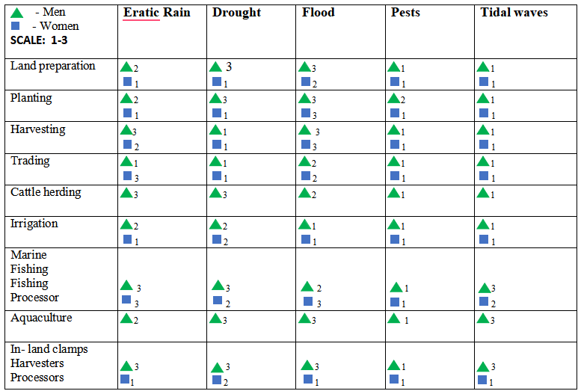
Figure 7: Stakeholders Ranking on the Impact of Climate Hazards on Gender groups

3.2.4. Assessing Resilience of Communities using a Matrix of Functions
The Matrix of Function (MoF) is a spatial planning tool that describes or signals aspects of adaptive capacity. When applied to climate change, the MoF enhances understanding of how the district’s current spatial structure enables or constrains its adaptive capacity and resilience to climate-related changes and impacts. The approach involves identifying climate hazards—such as droughts, floods, or heatwaves—and mapping them against essential functions that may be affected. This process helps reveal sectoral vulnerabilities and pinpoint critical areas where adaptation or mitigation interventions are needed.
For Ada East District, the MoF provides a detailed overview of the availability and distribution of services across communities, highlighting both strengths and gaps that shape local adaptive capacity. Public utilities and facilities remain unevenly distributed: basic services such as pipe-borne water, functional wells, and grid electricity are present in some towns but not consistently across all communities. Access to stormwater drainage and sewerage systems is particularly limited, heightening vulnerability during floods. While some households rely on private solar panels and rainwater harvesting, these remain isolated solutions rather than district-wide systems. Connectivity and communication infrastructure, including post offices and radio stations, is sporadic, resulting in uneven access to information and external linkages across communities.
Transport: Transport and road infrastructure in Ada East reveal notable imbalances. While both tarred and untarred roads exist, their reach does not extend to all settlements, and public transport services are inconsistently reliable across the district. Bus stations and petrol filling stations are concentrated in larger towns, limiting smaller communities’ integration into district trade and service networks. Markets play a central role in the district’s economy; local markets are common, but specialized livestock and fish markets are absent in many areas, restricting opportunities for fishers and farmers to trade beyond subsistence levels and constraining economic diversification.
Commercial Activities: Commercial establishments highlight the importance of informal and small-scale enterprises. Small stalls for basic goods and restaurants or chop bars are present across many communities, but larger establishments—such as hotels, guesthouses, and financial services—are concentrated in a few towns. Limited access to banks and mobile money services creates barriers to local entrepreneurship and reduces community resilience during shocks, as households struggle with savings, remittances, and access to credit.
Ecosystem Services: Provisioning ecosystem services underpin livelihoods in Ada East, with rice, maize, vegetables, and livestock widely cultivated or reared. However, production systems remain largely basic, with limited irrigation support and heavy reliance on rain-fed agriculture, leaving farmers highly vulnerable to rainfall variability. Livelihood diversity exists through activities such as charcoal production, herbal medicine, and oil extraction, but these are not systematically supported by infrastructure or market systems.
Healthcare: Health services exhibit another layer of uneven development. Community-based Health Planning and Services (CHPS) compounds and clinics exist, but public hospitals are limited to a few towns, and specialized medical staff such as dentists, midwives, and eye specialists are scarce. Pharmacies provide essential support where present, but the limited availability of advanced medical services forces many households to travel outside the district for care. Educational institutions follow a similar trend: kindergartens, primary schools, and junior high schools are available in many settlements, while secondary and vocational schools are concentrated in larger towns.
Cultural and Recreational Activities: Recreational and cultural facilities—including libraries, museums, and cultural centers—are largely absent, limiting knowledge sharing and cultural preservation. Security services are partially provided through police stations and checkpoints, but fire stations, evacuation points, and disaster management structures are underdeveloped, a concern given the district’s vulnerability to floods, tidal surges, and erosion. Community and religious organizations, particularly churches and mosques, are widespread and serve as important social anchors; however, organized NGOs, cooperatives, and civil society groups are less common, reducing opportunities for collective advocacy and coordinated climate action.
Local Economy: Own-account workers, including fishermen, carpenters, street vendors, and seamstresses, remain critical to Ada East’s local economy. These groups sustain household incomes through small-scale trades but face significant risks due to dependence on natural resources and limited financial or technical support. The absence of specialized professionals—such as accountants, licensed electricians, and plumbers—in many communities further underscores gaps in service diversity and economic specialization.
The matrix demonstrates that Ada East’s development is spatially uneven, with larger towns concentrating most infrastructure and services, while smaller communities remain underserved. This imbalance undermines the district’s adaptive capacity, as communities with fewer services and weaker institutional presence are less able to respond to climate-related shocks. Strengthening access to water, health facilities, educational institutions, financial services, and investing in ecosystem management and infrastructure are critical steps toward balancing spatial development and enhancing resilience across the district. The summarised matrix of function from the stakeholders is showed in the Appendix (Annex 1)

3.3 Quantitative Assessment of Vulnerability to Current Climate Change
This chapter presents the method (description of indicators derivation, data sources, data collection, data normalization, etc.) used to assess vulnerability. The results are presented in a descriptive approach of the VA in the district.

3.3.1 VA method, process and tools

3.3.1.1 Research design
Assessing the vulnerability of Ada East District requires a pragmatic comparison with other geographic locations and populations while identifying the unique factors that shape the district’s exposure, sensitivity and adaptive capacity to climate change (Williams et al., 2020). Guided by the IPCC framework, the vulnerability assessment approach for Ada East was structured around the three interrelated concepts of exposure, sensitivity and adaptive capacity, with processes designed to ensure a participatory and context-specific analysis.
The first stage involved a desktop review to establish an understanding of existing information and knowledge gaps relevant to Ada East’s climate vulnerabilities. The review provided a baseline by consolidating previous reports, climate data and socioeconomic information specific to the district. This exercise offered a comprehensive stocktake of what is already known about hazards such as floods, tidal surges, droughts and erosion and where new data collection efforts were necessary.
This was followed by stakeholder and expert consultations, which drew on local insights and technical expertise. The consultations combined Key Informant Interviews with district officials, traditional authorities, women’s groups and representatives from fishing and farming associations. These interactions not only validated findings from the desk review but also uncovered additional insights into the differentiated impacts of hazards across gender, age and livelihood groups. The consultations were conducted as part of Phase II of the vulnerability assessment, ensuring that community voices were central to shaping the narrative of risks and resilience. By bringing together these perspectives, the workshop served as a mechanism to refine and expand identified vulnerability indicators while considering context-relevant additions. The participatory and transparent nature of the workshop promoted stakeholder ownership of findings, enhanced awareness of local vulnerabilities and strengthened capacity to engage in future adaptation planning.
Across all stages, the approach was designed to identify indicators that capture both climate and non-climate stressors, including those related to socioeconomic inequalities, access to resources and governance challenges. Data collection methods were guided by these indicators, ensuring a balance between quantitative information and qualitative insights from communities. Through this process, Ada East’s vulnerability assessment not only highlighted the multiple risks facing the district but also provided a foundation for prioritizing adaptation measures that are evidence-based, inclusive and sensitive to the differentiated needs of its population.

3.3.1.2 Data collection for the community-based field survey

Sampling Methodology for Ada East District
The sampling method for the household survey in Ada East District was based on probabilistic random sampling with equal distribution across all communities. This approach was chosen to ensure that the survey captured perspectives from households spread across the diverse geographical and socio-economic settings of the district. By allocating the same number of respondents to each community, the design accounted for representation across both larger and smaller settlements, while simplifying fieldwork logistics and ensuring balance in data collection. Within each selected community, households (head of household) were randomly chosen to participate in the survey, ensuring that men, women, youth and other vulnerable populations had an equal chance of being included in the study.
The population figures were sourced from the Ada East District Assembly Development Planning Unit. Using Cochran’s formula for a finite population (76,411), the following parameters were applied:
- Cochran base n₀= ($\frac{Z^{2} x p(1-p)}{e^{2}} = \frac{{1.96}^{2} x 0.5(1-0.5) }{{0.05}^{2}} ≈ 384$
- Adjusted Sample Size with Ada East N=76,411
n= ($\frac{n_{0}}{1 + \frac{n_{0-1}}{N}} = \frac{384}{1 + \frac{383}{76,411}} ≈ 382$
Where, Z value = 1.96 for a 95% confidence level; Population Proportion (p) = 50% amd Margin of error (e) = 0.05
This yielded an adjusted minimum sample size of 382 households heads. The allocation of the sample across the 12 communities of Ada East was based on a non-proportional distribution. However, to account for potential non-responses, missing data and errors during fieldwork, the survey sample size was rounded up to 420 households assigning an equal quota of 35 respondents per community. This ensures robustness of the results and maintains the desired level of confidence and precision after data cleaning.
Table 3: Population Sampling for Ada East District
Zonal Council | Community | Sample Size
Kasseh Area Council | Torgbloku | 35
Kasseh Area Council | Kasseh | 35
Kasseh Area Council | Lufenya | 35
Kasseh Area Council | Kajanya | 35
Big Ada Area Council | Big Ada | 35
Big Ada Area Council | Obane | 35
Big Ada Area Council | Pediatorkope | 35
Big Ada Area Council | Atortokope | 35
Ada Foah Area Council | Aflive | 35
Ada Foah Area Council | Elavanyo | 35
Ada Foah Area Council | Azizanya | 35
Ada Foah Area Council | Otrokpe | 35
Total |  | 420

3.3.1.2 Data analysis for the IPCC-LVI
Information received from the overall assessment process has been consolidated to determine overall vulnerability of the district. Specifically for the quantitative assessment (survey), the data was analysed using STATA 15 software. The data analysis involved descriptive statistics comprising demographic characteristics of the respondents interviewed, their livelihood strategies and credit avenues, assets, social network, assess to social basic amenities and their prevailing exposure to climatic threats. The process firstly provides a descriptive insight into the context by applying an explorative statistical analysis. Further, analysis the livelihood vulnerability of the district was done by analysing the balanced-weighted average of the LVI based on the IPCC framework
As highlighted by Basiru et al., (2022), the LVI uses the balanced weighted approach. This is because each indicator subcomponent is measured differently using different units, the LVI formula thus applies equal weights to all the components. This is significant because, this method standardises each subcomponent into comparable units or indices. The standard balanced weighting approach applies equation 1.
${Index}_{C}=\frac{C-C_{min}}{C_{max}- C_{min}}$ … 1
Where ‘Indexc’ represents the subcomponent, C, being weighted and min and max represent the minimum and maximum values of subcomponent, C, respectively. After standardization of all indicators, the major components are generated by averaging the standardized scores of related subcomponents using Equation 2 below;
$H_{c}=\frac{\sum_{i=1}^{n}{{Index}_{C}}}{n}$ … 2
Where Hc represents one of the major components, the average of a summation of all subcomponents Index_{c,} of number, n. Finally, after calculating all the major components, a combination of the weighted averages for all major components was applied (Equation 3). This ensures equal contribution of the main components to the overall LVI (Sullivan, 2002).
$LVI=\frac{W_{SDP}SDP+ W_{ls}LS+ W_{SN}SN+ W_{H}H+ W_{F}F+ W_{P}P+ W_{W}W+ W_{ND}ND + W_{CV}CV }{W_{SDP}+ W_{LS}+ W_{SN}+ W_{H}+ W_{F}+ W_{P}+ W_{W}+ W_{ND}+ W_{CV}CV}$ … 3
where LVI is the Livelihood Vulnerability Index for NJSMA. This equals the average of the nine major components (socio-demographic profile (SDP), livelihood strategies (LS), social networks (SN), health (H), food (F), production (P), water (W), natural disasters (ND) and climate variability (CV)), each weighted by their number of subcomponents.
The LVI-IPCC indices were estimated from the weighted LVI main components and the standardized indicators (Equation 4). Changing events under climate variability and natural disaster occurrences was used in the estimation of exposure. Sensitivity was estimated by a district’s current state of health, food, production and water status. Adaptive capacity was also estimated by the socio-demographic profile, types of livelihood strategies employed and the strength of social network of surveyed households. The result of the LVI-IPCC falls into the range of -1 and +1. With − 1 representing least vulnerable score and + 1 representing the most vulnerable score.
$LVI-IPCC=\left(Exposure-Adaptive Capacity\right)*Sensitivity$ … 4
The same subcomponents used in the calculation of LVI are employed in the calculation of the LVI–IPCC with divergence in the combination of the major components. That is, rather than computing the LVI by combining the major components in the initial step, they were firstly merged according to the three main IPCC categorizations: exposure, sensitivity and adaptive capacity. Comparison of the IPCC contributing factors and the major components of the LVI rather than the overall score is applied in this VA process. Through the series of consultative expert meetings conducted, the research team reached consensus and selected the final set of vulnerability indicators. The participatory and consultative approach ensured the selection of context appropriate indicators as the indicators were relevant to the study context. The table in Appendix 3 summarises the finalized major LVI components and sources assessed for the study.
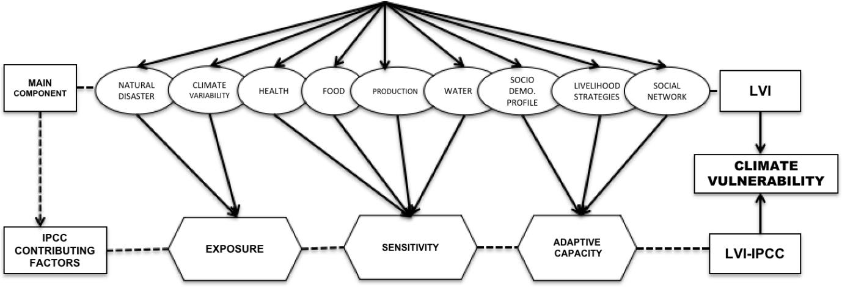
Figure 8: Grouping of major and subcomponents/indicators into LVI and LVI–IPCC

3.3.2 VA results and discussions

3.3.2 1 Socio-demographic characteristics
Ada East District exhibits a mixed livelihood system shaped by coastal, agrarian, and commercial activities. Agriculture dominates many communities, while trading, services, and salt mining drive economic life in market hubs and lagoon-adjacent areas. Gender distribution is generally balanced, though men dominate fishing and farming. The average age is 46, with younger populations in some towns and older populations in others. Educational attainment is uneven, with coastal and agrarian communities showing lower formal education and towns like Big Ada having greater access to secondary and tertiary levels. Household sizes are large, often supporting 6–8 dependents, and nearly 80% of residents have lived in their communities for over 20 years, though outmigration for work is common. These sociodemographic features highlight vulnerabilities linked to dependence on climate-sensitive livelihoods, limited education, and constrained alternatives, influencing exposure, sensitivity, and adaptive capacity across the district.

Gender and age profile
The survey was conducted across 12 selected communities within Ada East District, covering a total of 401 respondents (Table 1), of whom 220 were male (55%) and 181 female (45%). Overall, gender representation was fairly balanced across most communities, though some variations reflect the district’s social and occupational dynamics, particularly in fishing and farming areas, which are typically male-dominated. The average age of respondents was 46 years, with community-specific variations ranging from 40.6 years in Aflive to 51.8 years in Torgbloku. Torgbloku and Kasseh reported the oldest populations, with averages of 51.8 and 49.2 years respectively, while younger populations were recorded in Aflive (40.6 years), Obane (42.8 years), and Otrokpe (42.9 years). These differences suggest that certain communities have older populations, which may affect labor availability and influence vulnerability to climate risks, particularly in agriculture and fishing.
The demographic profile of Ada East District has important implications for climate resilience and development planning. The relatively mature age of respondents, combined with the concentration of older populations in certain communities, may limit labor availability for agriculture and fishing, sectors highly sensitive to climate variability. Gender imbalances in specific areas, driven by male-dominated occupations, could influence household decision-making and the distribution of adaptive responsibilities. Together, these factors suggest that targeted interventions such as support for older farmers, diversification of livelihoods, and inclusion of women in adaptive strategies are critical to enhancing the district’s overall adaptive capacity and resilience to climate risks.

Table 4: Gender and Age distribution of the respondents
Community | Gender of respondent |  | Average Age of respondents | Total Number of Respondents
Community | Male | Female | Average Age of respondents | Total Number of Respondents
Aflive | 26 | 9 | 40.6 | 35
Azizanya | 25 | 10 | 44.5 | 35
Big Ada | 19 | 24 | 47.6 | 43
Elavanyo | 19 | 22 | 48.4 | 41
Kajanya | 26 | 9 | 45.8 | 35
Kasseh | 14 | 21 | 49.2 | 35
Lufenya | 21 | 13 | 43.7 | 34
Obane | 11 | 19 | 42.8 | 30
Otrokpe | 26 | 10 | 42.9 | 36
Pediatorkope | 5 | 5 | 48.8 | 10
Atortokope | 12 | 20 | 46.6 | 32
Torgbloku | 16 | 19 | 51.8 | 35
Total | 220 | 181 |  | 401

Education Levels
The survey revealed significant variations in educational attainment across Ada East District. While most respondents had basic education, non-formal education remained substantial, particularly in coastal communities. Communities such as Obane, Otrokpe, and Kasseh recorded the highest shares of respondents with no formal education—sometimes exceeding 70% whereas Big Ada, Elavanyo, and Kajanya showed higher levels of secondary and vocational education. Tertiary education was limited but more visible in Kajanya, Lufenya, and Torgbloku, with up to 10% of respondents reporting university or polytechnic-level training. These findings highlight intra-district disparities and reflect broader national trends, where rural coastal areas face challenges in access to quality education compared with urban centers.
The uneven educational profile has important implications for adaptive capacity and development planning. Communities with low literacy are likely to face greater challenges in accessing information, adopting climate-smart practices, and participating in diversified livelihood opportunities. Addressing these gaps through targeted educational interventions particularly in non-formal and secondary education—would strengthen human capital, enhance resilience to climate risks, and promote equitable development across the district.

‘

Figure 9: Levels of education across communitties in Ada East District

Primary Occupation
Livelihoods in Ada East District are highly diverse, shaped by its coastal, agrarian, and commercial communities. Fishing is the largest primary occupation, engaging 25% of respondents, particularly in coastal settlements such as Azizanya (80%), Aflive (66%), and Otrokpe (58%). Agriculture employs 21%, concentrated in inland communities like Elavanyo (46%), Kajanya (43%), and Lufenya (56%), focusing on cassava, maize, and vegetables. The private sector dominates employment for 38% of respondents, especially in trading, small businesses, and services in commercial hubs such as Kasseh (94%), Big Ada (51%), and Atortokope (59%). Civil service employment is limited (6%) but notable in key towns. Other livelihoods include salt mining (3%), primarily in Lufenya. Unemployment is low (3.5%), reflecting widespread engagement in various livelihood activities.
The district’s livelihood diversity supports household resilience but also indicates varying exposure to climate risks. Coastal fishing communities are highly vulnerable to tidal surges, sea-level rise, and changing fish stocks, while inland farmers face risks from erratic rainfall and drought. Dependence on small-scale trading and informal businesses may limit income stability during economic or climate shocks. Targeted interventions such as climate-smart agriculture, sustainable fisheries management, livelihood diversification, and support for informal sector actors are critical to strengthening adaptive capacity and reducing vulnerability across Ada East.

Figure 10: Primary occupation of respondents

Household dependents
Household sizes in Ada East District tend to be medium to large. Across the district, 41% of households have 3–5 dependents, 34% have 6–8, and 18% have 9 or more, while only 7% report two or fewer. Larger households are common in coastal and agrarian communities such as Azizanya (77% with ≥6 dependents), Elavanyo (78%), and Otrokpe (67%), reflecting reliance on household labor for fishing and farming. Smaller households are more prevalent in commercial hubs like Big Ada (12% ≤2 dependents), Kajanya (9%), and Torgbloku (20%), where economic activities rely less on family labor. Pediatorkope’s households largely fall within the 3–8 range.
Larger households in fishing and farming communities may provide labor advantages but also increase dependency pressures, heightening vulnerability to climate shocks and economic instability. Smaller households in commercial areas may have more flexible income sources but rely less on internal labor, affecting resilience differently. Understanding these household dynamics is critical for designing targeted interventions in food security, livelihood support, and social protection programs across the district.

Figure 11: Household dependents

Origin of respondents and period of stay in communities
Long-term residency is prevalent across Ada East District, with 79% of respondents having lived in their community for over 20 years, 15% between 11–20 years, 5% for 5–10 years, and only 1.5% for less than five years. Coastal communities such as Otrokpe (100%), Azizanya (97%), and Aflive (97%) exhibit particularly entrenched populations, while Atortokope shows greater population fluidity, with 59% reporting fewer than 20 years of residence. Inland agrarian communities like Elavanyo (73%) and Kajanya (86%) also demonstrate high settlement permanence. Commercial centers such as Big Ada and Kasseh, although still dominated by long-term residents, display somewhat higher turnover. Overall, these patterns indicate limited migration and strong attachment to land, sea, and community resources, especially in coastal and fishing settlements.

Figure 12: Period of stay in communities

Household Members Working Outside
Outmigration is widespread in Ada East, with 47% of households reporting at least one member working outside their community. The highest levels are observed in Obane (73%), Kajanya (63%), and Atortokope (59%), where limited local economic opportunities drive reliance on remittances. Moderate outmigration occurs in Big Ada (42%), Elavanyo (52%), and Aflive/Azizanya (49%), while Otrokpe (8%) and Pediatorkope (30%) report much lower levels, indicating greater dependence on local resources. This pattern highlights a clear divide: inland and resource-limited communities rely more on external labor, whereas coastal fishing communities, despite higher exposure to hazards, remain more dependent on immediate local livelihoods.
High outmigration in inland and resource-limited communities indicates dependence on remittances to supplement livelihoods, which can buffer households against local economic or climate shocks but may also reduce labor availability for agriculture and local development activities. Conversely, low outmigration in coastal fishing communities suggests strong reliance on local resources, which increases exposure to climate hazards such as floods, tidal surges, and sea-level rise. These patterns highlight the need for tailored interventions: supporting income diversification in inland communities and enhancing climate-resilient livelihood options in coastal areas to strengthen adaptive capacity across Ada East.

Figure 13: Household Members Working Outside

Summary of Ada East Socio-demographic Profile
Sociodemographic Variable | Key Findings | Implications for Climate Vulnerability
Gender & Age | 55% male, 45% female; average age 46 years; older populations in Torgbloku (51.8 yrs) and Kasseh (49.2 yrs); younger in Aflive and Obane. | Older populations may have reduced labor capacity for adaptation; male dominance in fishing and farming exposes households to sector-specific risks.
Education | High illiteracy in Obane, Otrokpe, and Kasseh (>70% no formal education); stronger attainment in Kajanya, Big Ada, and Torgbloku; tertiary education rare (≤10%). | Limited education reduces access to climate information and alternative livelihoods, constraining adaptive capacity in vulnerable communities.
Primary Occupation | Fishing (25%) dominates Azizanya, Aflive, Otrokpe; Agriculture (21%) in Elavanyo, Kajanya, Lufenya; Private sector (38%) in Kasseh, Big Ada; Salt mining (3%) in Lufenya and Aflive. | Dependence on fishing and farming increases exposure to rainfall variability, flooding, and coastal hazards; traders in hubs like Kasseh may diversify risks but remain sensitive to infrastructure disruption.
Household Dependents | 41% have 3–5 dependents; 34% have 6–8; 18% have 9+; large families in Azizanya, Elavanyo, and Otrokpe. | Large households heighten sensitivity to food insecurity and resource stress during climate shocks, but can also provide labor for adaptation in agrarian and fishing economies.
Origin & Period of Stay | 79% lived in communities over 20 years; long-term residency in Otrokpe (100%), Azizanya (97%), and Aflive (97%); more fluidity in Big Ada and Kasseh. | Entrenched settlement ties increase exposure to local hazards, particularly in coastal and low-lying areas, and reduce mobility as an adaptation option.
Household Members Working Outside | 47% of households have migrants; highest in Obane (73%), Kajanya (63%), and Atortokope (59%); lowest in Otrokpe (8%) and Pediatorkope (30%). | Migration and remittances provide financial buffers for inland and resource-limited communities, while fishing-dependent settlements remain highly exposed to local climate risks.

3.3.2.2 IPCC-LVI Results
This section presents the results of the IPCC-LVI for Ada East District, highlighting vulnerabilities at both the community and sectoral levels. The assessment builds on the three IPCC dimensions—exposure, sensitivity, and adaptive capacity—to generate a composite index of vulnerability across the district. The index is standardized on a scale from –1 to +1, where values closer to –1 represent higher levels of vulnerability.
In this assessment, adaptive capacity is measured using a deficit-based approach, where indicators capture the absence or inadequacy of critical resources and services. This framing emphasizes the structural gaps that weaken resilience and illustrates how communities remain constrained in their ability to cope with climate risks. High hNegative values can therefore be interpreted as clear markers of heightened vulnerability when assessed together with exposure and sensitivity scores.

3.3.2.2.1 Vulnerable Sectors
The sectoral analysis of the IPCC-LVI highlights how climate change impacts are distributed across the main economic sectors of Ada East district.
Community | Health | Infrastructure | Water resources | Agriculture | Services sector | DRR | Gender
Aflive | -0.089 | -0.118 | -0.050 | -0.057 | -0.071 | -0.119 | -0.070
Azizanyo | -0.101 | -0.159 | -0.071 | -0.095 | -0.111 | -0.041 | -0.059
Elavanyo | -0.075 | -0.097 | -0.055 | -0.083 | -0.097 | -0.136 | -0.674
Otrope | -0.048 | -0.054 | -0.027 | -0.084 | -0.061 | -0.060 | -0.080
Big Ada | -0.094 | -0.128 | -0.114 | -0.317 | -0.102 | -0.136 | -0.066
Obane | -0.171 | -0.240 | -0.112 | -0.217 | -0.143 | -0.096 | -0.019
Pediatorkope | -0.146 | -0.172 | -0.146 | -0.074 | -0.158 | -0.061 | -0.074
Atortokope | -0.075 | -0.114 | -0.126 | -0.140 | -0.095 | -0.090 | -0.024
Kajanya | -0.201 | -0.225 | -0.173 | -0.327 | -0.195 | -0.193 | -0.063
Kasseh | -0.201 | -0.188 | -0.108 | -0.433 | -0.126 | -0.196 | -0.023
Lufenya | -0.175 | -0.192 | -0.191 | -0.179 | -0.192 | -0.193 | -0.049
Torgbloku | -0.103 | -0.122 | -0.104 | -0.105 | -0.125 | -0.121 | -0.027
Sector Average LVI | -0.123 | -0.151 | -0.106 | -0.176 | -0.123 | -0.120 | -0.102
Table 5: Sectoral Vulnerability of Ada East District

Agriculture (most vulnerable)
Agricultural vulnerability in Ada East is driven by high exposure to erratic rainfall, prolonged dry spells, occasional tidal overtopping, and saline intrusion, which degrade soils and contaminate shallow irrigation sources. Sensitivity is elevated because production is largely rain-fed, crop diversity is limited (maize, cassava, vegetables), and pest and disease pressure increases with heat and humidity. Short planting windows, water stress, and salinity rapidly translate into yield losses. Adaptive capacity is constrained by limited irrigation, weak farmer organization, restricted access to credit or insurance, and uneven extension services, which slow the adoption of drought- and salt-tolerant varieties, soil moisture conservation, and safe water management. Heavy rains disrupting feeder roads and markets, particularly along the Kasseh–Big Ada corridor, further reduce farm-gate prices while increasing input and transport costs. With limited income diversification or remittance support, even moderate seasonal anomalies trigger food insecurity, distress sales of assets, and reduced investments in subsequent seasons. These interacting factors explain why agriculture ranks highest in the district’s vulnerability profile and why localized shocks propagate quickly across livelihoods.

Infrastructure
Infrastructure vulnerability reflects assets exposed to hazards and systems that cannot absorb shocks. Exposure is high where roads, culverts, schools, clinics, and market streets are located in low-lying flood corridors, estuarine fringes, or eroding shorelines without full protection. Sensitivity is pronounced, as small drainage failures or bank erosion immediately interrupt mobility, schooling, healthcare access, and market operations; even shallow inundation damages pavements, subgrades, and equipment. Adaptive capacity is limited by deferred maintenance, unclear responsibilities for drain desilting, scarce emergency budgets, and weak community organization. Minor storms can therefore cause road blockages, long detours for traders and patients, and unplanned closures of public facilities.

Health
Health vulnerability is amplified by post-flood contamination, heat, and stagnant water around dense settlements and markets. Sensitivity is heightened by sanitation and solid-waste bottlenecks, intermittent safe water, and vector breeding in poorly drained areas, leading to disease spikes such as malaria after inundation. Adaptive capacity is constrained by stretched primary care services, limited surge supplies, fragile cold chains, and disrupted access due to damaged roads. Households with minimal cash reserves or institutional support face delays in seeking care, prolonging illness and raising treatment costs. Environmental-health enforcement and climate-sensitive surveillance struggle to keep pace with drainage and waste challenges, meaning even short flood events produce measurable morbidity and slow recovery.

Services Sector
Service-sector vulnerability reflects dependence on accessible, dry public spaces and reliable infrastructure. Exposure arises from market flooding, eroded verges, and heat or damp conditions that damage perishable stock and equipment. Sensitivity is acute: brief waterlogging collapses footfall, disrupts last-mile logistics, and breaks cold chains. Adaptive capacity is limited where traders lack associations for pooled risk, have thin cash reserves, no insurance, and under-adopt business-continuity practices (e.g., elevated stock or protected storage). Because many households depend on petty enterprise, even short closures erode working capital and reduce purchasing power, prolonging demand slumps after hazards recede.

Disaster Risk Reduction (DRR)
DRR vulnerability is primarily organizational. Exposure to tidal surges, riverine flooding, and heavy rainfall is recurrent, while sensitivity remains high where early-warning systems are uneven, evacuation routes cross flood-prone areas, and shelters lack essentials (lighting, water, sanitation, first aid). Adaptive capacity is constrained by limited community mobilization, inadequate equipment and training, sparse pre-positioned supplies, and weak coordination among local actors. Low social-group membership reduces volunteer availability, slowing household-level protective actions such as elevating assets or pre-packing emergency kits. Debris clearance and relief targeting are delayed by logistical gaps and unclear roles, causing recurrent losses in the same hotspots despite awareness of hazards.

Water Resources
Water vulnerability reflects both hazard exposure and service challenges. Households face dry-season scarcity, flood contamination, and saline intrusion into estuarine and coastal aquifers. Sensitivity arises when sources fail or turn brackish, forcing households to queue, purchase alternatives, or ration water, undermining hygiene, food preparation, childcare, and small-scale processing. Adaptive capacity is limited where borehole rehabilitation and chlorination are sporadic, storage and rainwater harvesting are insufficient, user-committee governance is weak, and household finances constrain maintenance. Inundation of poorly protected wells increases microbial risk, while extended dry spells heighten dependence on costly alternatives. Frequent outages and uncertain quality erode trust in supply, prompting expensive coping strategies and increasing WASH-related health risks.

Gender (Cross-Cutting Amplifier)
Gendered vulnerability in Ada East is shaped by roles, resources, and representation. Exposure is structured by women’s central responsibilities in water collection, childcare, processing, and trade all of which are directly affected by WASH failures, market closures, and mobility constraints during floods or heatwaves. Sensitivity rises as unpaid care and provisioning expand while earnings from processing or trade contract, intensifying time poverty and limiting participation in training or producer networks. Adaptive capacity is constrained by limited access to credit and land, low group membership, and minimal formal support, reducing options for preventive investments, rapid restocking, and autonomous protective actions. These constraints amplify losses across agriculture, health, services, and water sectors, slowing household and community recovery even when sectoral services are restored.

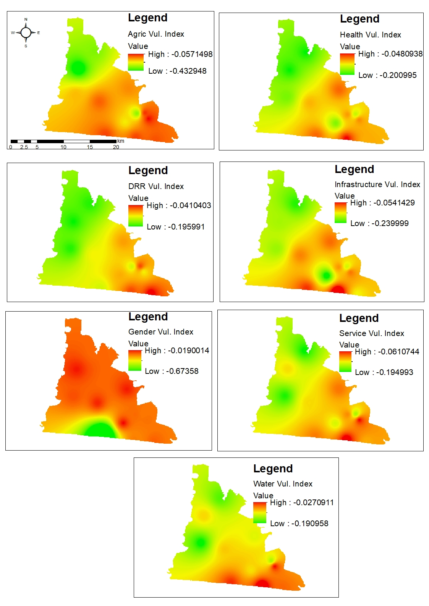
Figure 14: IPCC-LVI heat map for economic sectors in Ada East District

3.3.2.1.2 Vulnerable locations
Comparing the contributions of the three vulnerability factors (Table 4), Azizanya, Aflive, and Elavanyo emerge as the most exposed to climate impacts. Residents of Azizanya and Aflive occupy low-lying coastal and estuarine zones, making them highly susceptible to recurrent tidal surges, sea-level rise, and saline intrusion. Limited sea defenses and inadequate drainage further exacerbate their flood and storm-surge exposure. Similar conditions are observed in Elavanyo and Otrokpe, where proximity to the Volta estuary and wetland systems increases geographic vulnerability to both riverine and coastal flooding.
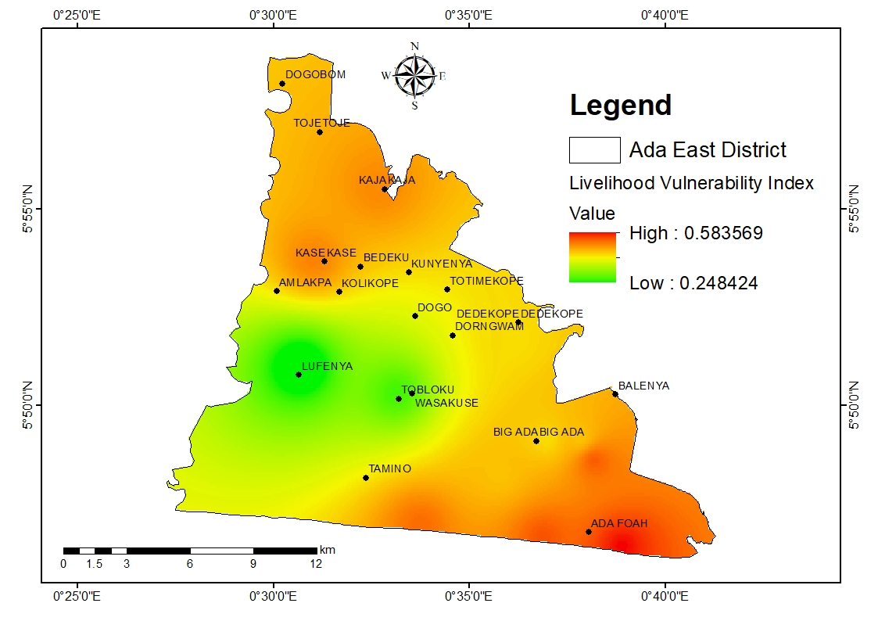
Figure 15: IPCC-LVI heat map of Communities’ Vulnerability
The most sensitive communities include Lufenya, Kajanya, and Atortokope, which frequently experience climate-related damages such as crop losses, water scarcity, and pressures from both climate and non-climate stressors. Sensitivity in these areas is closely linked to dependence on rain-fed agriculture, poor soil quality, and limited livelihood diversification. Farmers in Kajanya and Lufenya, in particular, report that prolonged dry spells and erratic rainfall disrupt planting seasons, while limited access to irrigation exacerbates vulnerability to drought.

Households in flood-prone coastal and estuarine areas with inadequate drainage, degraded protective ecosystems, and fragile road networks were found to be highly exposed. Similarly, inland agricultural communities heavily reliant on climate-sensitive livelihoods are more sensitive to changes in rainfall and temperature. By contrast, communities such as Big Ada and Kasseh, which serve as commercial and service hubs, exhibit relatively higher adaptive capacity. Their proximity to markets, schools, and health facilities, combined with more diversified livelihood opportunities and stronger social networks, helps mitigate climate risks.

Regarding adaptive capacity, communities such as Obane, Pediatorkope, and Lufenya show lower capacity to cope with climate vulnerability compared to Azizanya, Otrokpe, Big Ada, and Kasseh. This is primarily due to weaker socio-demographic profiles and limited livelihood options, with households heavily dependent on rain-fed agriculture and fewer opportunities for income diversification or access to broader markets. In contrast, Kasseh and Big Ada benefit from stronger social networks and better access to services, which enhance resilience. Overall, differences in adaptive capacity across Ada East are largely shaped by the strength of social networks and the availability of alternative livelihoods beyond farming and fishing (Table 5). Detailed results for the corresponding indicators of the IPCC-LVI are presented in Appendix 2.

Table 6: IPCC‑LVI results for Ada East District
Community | EXPOSURE | SENSIVITY | ADAPTIVE CAPACITY | IPCC-LVI
Aflive | 0.471 | 0.464 | 0.635 | -0.076
Azizanyo | 0.584 | 0.387 | 0.747 | -0.063
Elavanyo | 0.435 | 0.360 | 0.750 | -0.113
Otrope | 0.485 | 0.411 | 0.738 | -0.104
Big Ada | 0.306 | 0.288 | 0.683 | -0.108
Obane | 0.386 | 0.326 | 0.617 | -0.075
Pediatorkope | 0.427 | 0.439 | 0.512 | -0.037
Atortokope | 0.348 | 0.344 | 0.605 | -0.088
Kajanya | 0.280 | 0.518 | 0.610 | -0.171
Kasseh | 0.317 | 0.349 | 0.779 | -0.161
Lufenya | 0.289 | 0.568 | 0.559 | -0.153
Torgbloku | 0.405 | 0.422 | 0.560 | -0.065

Overall, all the zonal councils in the district showed relatively high vulnerability to climate change. The main observations about vulnerable locations are summarized below:
Kajanya: Water scarcity is the most pressing issue. Households spend significant amounts on purchased water, and the absence of reliable supply systems makes daily life challenging. This dependence undermines livelihoods and creates tensions during prolonged dry periods.
Atortokope: Water insecurity is severe, with residents facing both high costs and unreliable quality. Inadequate sanitation further compounds health risks, leaving the community highly vulnerable to waterborne diseases.
Lufenya: Similar conditions prevail, with families struggling with high water expenses and insufficient public facilities, increasing susceptibility to disease outbreaks and limiting resilience.
Kasseh: As the district’s main market hub, commercial activity masks underlying vulnerabilities. Poor drainage and recurring erosion damage property during heavy rains, while limited waste management and inadequate sanitation pose ongoing health risks. Seasonal flooding and unreliable clean water access continue to affect residents despite the town’s relatively better connectivity to services.
Big Ada: This commercial town faces comparable challenges. Residents report difficulty accessing emergency health care, while water shortages remain persistent, highlighting vulnerabilities despite economic vibrancy.
Atortorkope and Obane: Among the most deprived communities, both suffer from poor road networks, lack of public toilets, and inadequate health facilities, leaving residents exposed during emergencies. Low-lying terrain increases flood risk, and reliance on subsistence farming ties vulnerability directly to erratic rainfall and soil degradation. The lack of infrastructure limits both coping capacity and recovery.
Azizanya and Elavanyo: Coastal settlements are directly exposed to tidal surges and shoreline erosion. In Elavanyo, fishing, okada riding, and small-scale farming provide income, but basic amenities such as community toilets, potable water, markets, and health facilities are lacking. In Azizanya, the absence of proper sanitation leads many households to use the sea as an open toilet, increasing the risk of waterborne diseases, particularly during flooding.
Pediatorkope: This small island community faces compounded vulnerabilities due to limited infrastructure and services, isolating residents from markets, health care, and education. Fishing and basket weaving are the main livelihoods, but exposure to flooding and isolation during high tides heightens insecurity and dependence on external support.

3.3.2.3 Climate Exposure
Exposure to climate hazards in Ada East closely reflects the district’s geography along the Gulf of Guinea and the Volta River estuary. Coastal and estuarine settlements record the highest exposure scores. Azizanya (0.584) and Otrokpe (0.485), both situated at the estuary’s edge, experience recurrent tidal surges, saline intrusion, and estuarine flooding that regularly displace households and damage property. Aflive (0.471), a shoreline settlement, and Elavanyo (0.435) also fall within the high-exposure range, consistent with their proximity to flood-prone coastal and lagoon systems.
In contrast, inland settlements such as Big Ada (0.306), Kajanya (0.280), and Lufenya (0.289) show lower exposure, being farther removed from direct tidal and estuarine influences. Kasseh (0.317), the district’s main commercial hub, also records relatively low exposure. Nevertheless, these inland and market-oriented communities remain vulnerable to seasonal flooding from poor drainage and to water shortages during prolonged dry spells.
The spatial pattern indicates that exposure is highest in coastal and estuarine communities, moderate in river-fringe settlements, and lowest in inland or market towns. Field observations support these findings, with enumerators reporting severe tidal flooding and shoreline erosion in Azizanya and Elavanyo, while inland communities such as Kajanya and Lufenya face water scarcity.
The geographic concentration of exposure highlights that coastal and estuarine communities are particularly vulnerable to climate hazards, necessitating targeted interventions such as shoreline protection, flood defenses, and improved drainage. Inland and market towns, while less exposed to direct tidal impacts, require measures to address seasonal flooding and water scarcity to protect livelihoods and maintain service continuity. Spatially differentiated adaptation strategies are therefore critical to enhance resilience across the district.
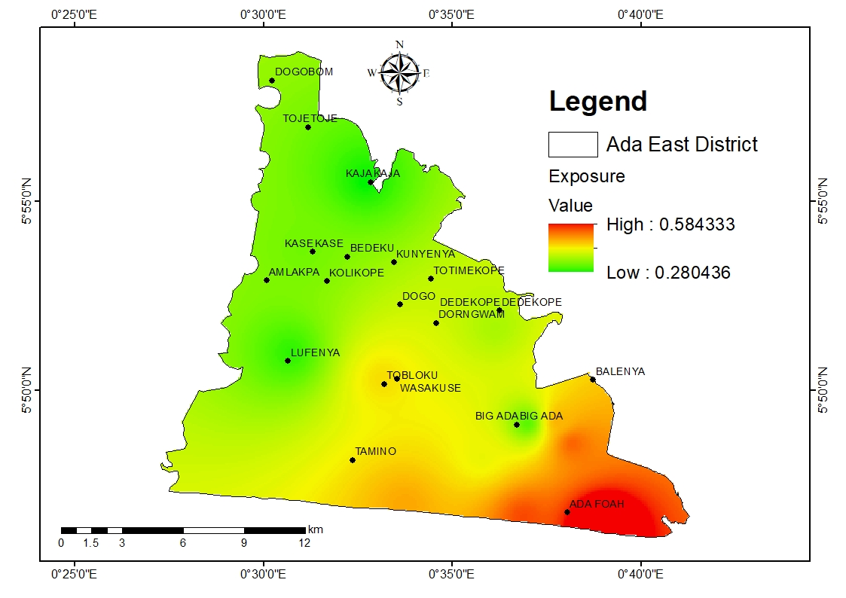
Figure 16: Climate Exposure of Ada East

3.3.2.4 Climate Sensitivity
Sensitivity in Ada East is largely driven by reliance on climate-sensitive livelihoods—farming, fishing, and salt mining—combined with fragile WASH systems. The highest sensitivity scores are observed in Lufenya (0.568) and Kajanya (0.518), inland communities where severe water scarcity forces households to spend heavily on purchased water. Enumerator observations confirm that inadequate facilities and limited livelihood options amplify risks in these areas. Pediatorkope (0.439), a small island settlement on the Volta River, also exhibits elevated sensitivity due to its isolation, poor infrastructure, and dependence on seasonal fishing.
Coastal settlements such as Aflive (0.464) and Otrokpe (0.411) show moderate sensitivity, reflecting disruptions from tidal surges and flooding that contaminate water supplies and damage farmland. Communities like Big Ada (0.288) and Elavanyo (0.360) report relatively lower sensitivity, supported by better access to services, stronger markets, and more diversified economic activities.
Overall, sensitivity is greatest in inland farming and island communities, where access to water, health, and sanitation is most limited. Coastal communities remain vulnerable but benefit from diversified economies.
High sensitivity in inland and island communities underscores the need for targeted interventions to improve water access, sanitation, and livelihood diversification. Strengthening basic services and supporting alternative income sources can reduce vulnerability and enhance resilience. Coastal communities, while less sensitive due to economic diversity, still require measures to protect water quality and agricultural productivity during flooding and tidal surges.

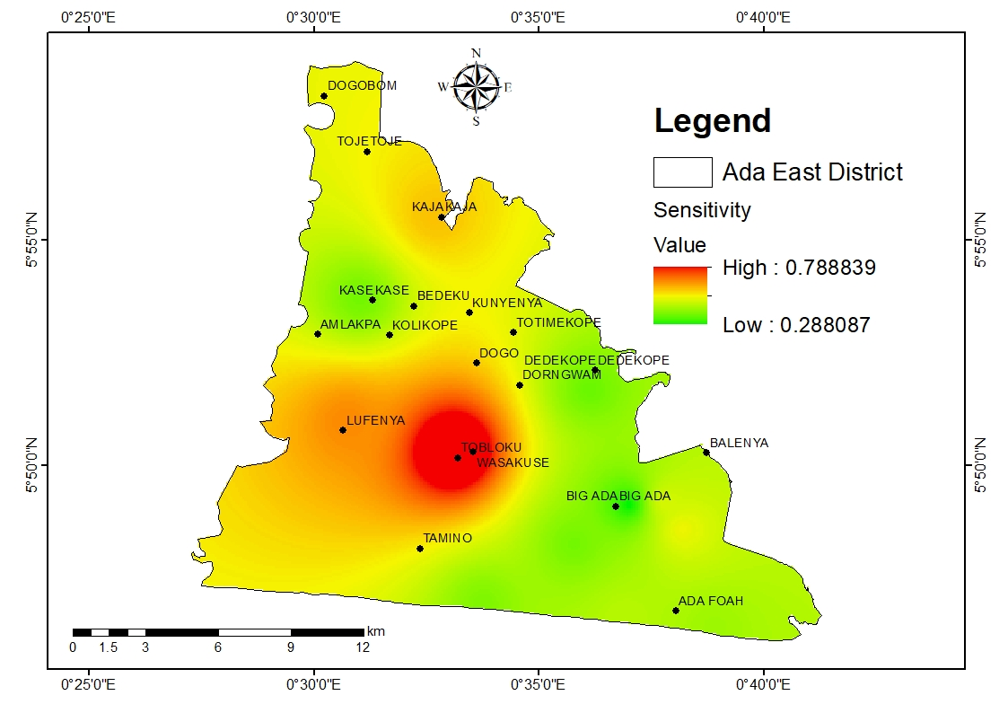
Figure 17: Climate Sensitivity of Ada East District - Heat map

3.3.2.5 Adaptive Capacity
Adaptive capacity in Ada East varies considerably, influenced by socio-demographic factors, livelihood diversification, and social networks. Market hubs such as Kasseh (0.779) and Big Ada (0.683) exhibit the highest adaptive capacity, with strong commercial activity, extensive social connections, and better access to infrastructure and services enabling households to respond effectively to climate shocks. Coastal communities like Azizanya (0.747), Elavanyo (0.750), and Otrokpe (0.738) also demonstrate relatively high adaptive potential, supported by diversified fishing, farming, and trading activities, as well as cohesive social networks.

In contrast, Pediatorkope (0.512) and Torgbloku (0.560) have the lowest adaptive capacity. Pediatorkope’s isolation limits access to markets, schools, and health facilities, while Torgbloku faces weaker social networks and fewer alternative livelihood options. Lufenya (0.559) also exhibits lower adaptive potential, reflecting socio-demographic constraints and high reliance on vulnerable rain-fed agriculture. Although all communities have negative IPCC-LVI scores—indicating that adaptive capacity currently mitigates some exposure and sensitivity—the margin is thin in isolated and resource-stressed areas.
Enhancing adaptive capacity in Ada East requires targeted investments in infrastructure, including potable water, sanitation, health facilities, and market access, particularly in isolated inland and island communities. Strengthening social networks, promoting livelihood diversification, and improving connectivity will further enable households to respond to climate shocks, reducing vulnerability and supporting sustainable development across the district.

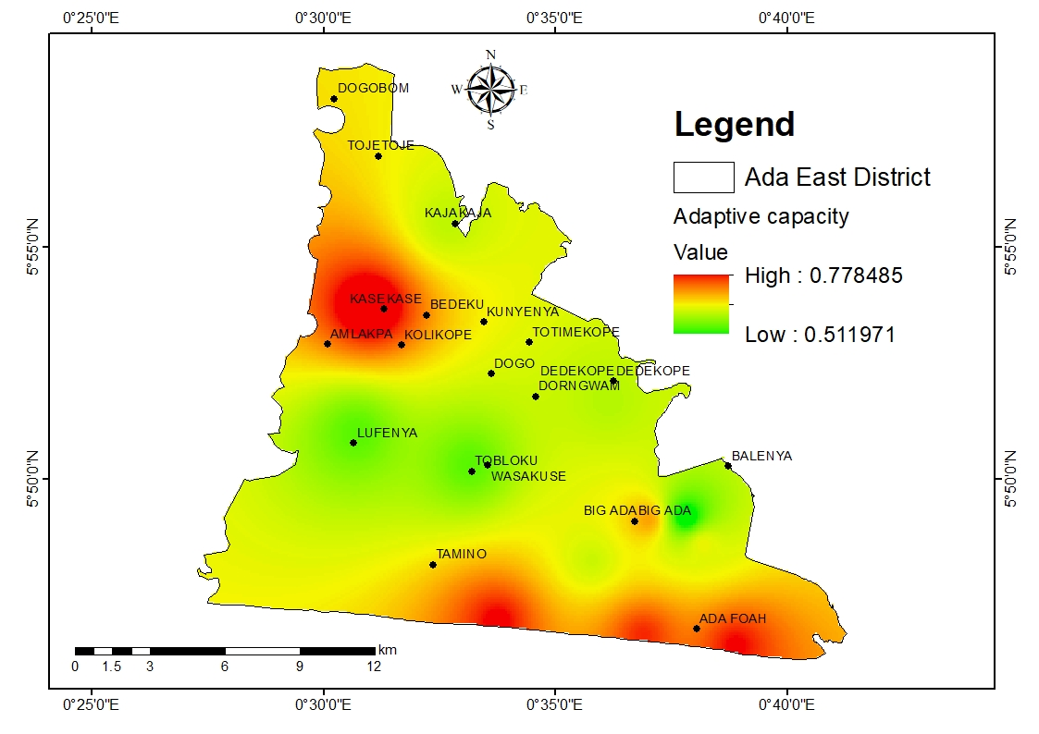
Figure 18: Adaptive Capacity Heat Map of Ada East District

3.3.2.6 Gender dimensions of vulnerability
The vulnerability of Ada East District to climate change is strongly influenced by gender dynamics, as roles, responsibilities, and access to resources are unevenly distributed between men and women. Survey results indicate that these disparities shape exposure, sensitivity, and adaptive capacity across households. While decision-making is often joint, men retain greater independent authority over key livelihood areas. For instance, although more than half of households make financial decisions jointly, men account for the largest share of sole decision-making, and women the smallest. Similarly, about two-thirds of farming decisions are made jointly, but nearly a third are made by men alone, with women again holding the least influence.
These patterns reflect broader district realities: women contribute substantially to farming, trading, and household provisioning, yet limited autonomy in critical livelihood choices reduces their capacity to independently respond to climate shocks. Gender disparities in decision-making constrain women’s adaptive capacity, leaving them disproportionately vulnerable during climate events. Strengthening women’s access to resources, credit, training, and decision-making power alongside promoting inclusive household and community governance—can enhance resilience, improve adaptive responses, and ensure that both men and women contribute effectively to climate adaptation strategies in Ada East.

Figure 19: Household Decision Making
Water scarcity highlights one of the most pronounced gendered vulnerabilities in Ada East. In communities such as Kajanya, Lufenya, and Togbloku, enumerators observed that households spend significant sums purchasing water due to saline intrusion and unreliable supply. Survey findings indicate that over three-quarters of households rely on women to fetch water, while men rarely assume this responsibility. This dynamic means that women bear both the physical burden of water collection and the financial stress of securing water during shortages. Consequently, their time for income-generating activities is reduced, and their exposure to climate risks increases when dry spells are prolonged.

Fishing and coastal livelihoods reveal similar gender disparities. In estuarine communities like Azizanya and Elavanyo, men dominate offshore fishing, while women are responsible for processing and trade. When flooding or tidal surges reduce fish catches, men lose immediate harvests, but women lose access to raw fish for processing. The survey also shows that fewer than one in ten households report women having equal access to credit, limiting their ability to recover trading businesses after climate shocks. This financial exclusion undermines women’s adaptive capacity, despite their critical role in sustaining household food security.

Figure 20: Household Tasks roles and responsibility
Childcare and domestic responsibilities further increase women’s sensitivity to climate impacts. The survey found that while most childcare is shared between men and women, women assume a larger share when responsibilities are not equally distributed. This pattern is evident in communities such as Obane and Atortorkope, where limited access to health facilities forces women to spend additional time caring for children and elderly relatives during floods or disease outbreaks. These obligations reduce women’s availability for income-generating activities, heightening their vulnerability when livelihoods are disrupted.
Access to resources provides another perspective on gender inequality. Just over half of respondents reported that women have equal access to land, while the remainder indicated contested or male-dominated access. Access to credit is even more restricted: fewer than one in ten households confirmed equal female access, leaving women dependent on men or shared arrangements. Similarly, although over 90 percent of households reported that access to information is shared, very few women have independent control. These dynamics demonstrate that women often rely on male intermediaries for climate-related knowledge, which can delay or limit their ability to act swiftly in emergencies.

Figure 21: Women Climate Adaptive Capacity
Institutional support for women is largely absent in Ada East. The survey found that nearly all households reported no organizations assisting women with climate adaptation, with only a few acknowledging any form of financial support. This lack of structured backing forces women to rely on informal networks, despite their disproportionate responsibilities in water collection, childcare, and household food security.

Figure 22: Access to resources
In summary, the survey data highlight how gender dynamics amplify vulnerability in Ada East. Men retain greater authority over financial and farming decisions, while women despite their central roles in water collection, childcare, and food processing have limited access to credit, land, and institutional support. The heavy reliance on women for water provision, their minimal independent decision-making over household resources, and the near absence of structured adaptation support collectively demonstrate how climate risks intersect with and exacerbate existing gender inequalities.

CHAPTER 4: ASSESSMENT OF VULNERABILITY TO FUTURE CLIMATE CHANGE
This chapter presents the method (description of indicators derivation, data sources, data collection, data normalization, etc.) used to assess vulnerability. The results are presented in a descriptive approach of the VA in the district. The chapter further assesses future climate change risk (Summary of climate change projections and Potential impacts and future climate change risks) explaining how projected changes in climate can affect the district in future under business−as−usual scenario

4.1 Climate Change Projections

4.1.1 Description of the Climate Projection Method
The climate projection for Ada East District was undertaken using the Coupled Model Intercomparison Project Phase 6 (CMIP6) framework, which provides multi-model ensembles of future climate under different emission and socioeconomic scenarios. The Shared Socioeconomic Pathways (SSPs), specifically SSP2-4.5 (a stabilization pathway) and SSP5-8.5 (a high-emission scenario), were selected to capture moderate and extreme futures. The projections were benchmarked against observed historical data from the Ghana Meteorological Agency and international climate datasets to assess long-term variability and emerging trends.

4.1.2 Data Collection for Climate Projection
The dataset comprised daily and monthly historical climate data spanning over 40 years, including precipitation and temperature records. These were supplemented by gridded datasets and reanalysis products, which were bias-corrected against observed station data for Ada East and surrounding districts. Climate indices were computed to evaluate rainfall characteristics (e.g., annual totals, consecutive dry days, heavy rainfall events) and temperature extremes (e.g., heatwave duration, warm nights, diurnal temperature range). This data framework ensured that both mean climate conditions and extremes relevant to livelihoods were captured.
To make the analysis robust, data were drawn from both observed records and climate model outputs. For the baseline and bias correction, CHIRPS rainfall data, which combine satellite and ground station observations at a fine resolution of 0.05° (about 5 km), were used alongside ERA5 reanalysis, which integrates weather observations and models to provide hourly temperature and humidity data at 0.25° (about 30 km) resolution. For future climate projections, the analysis relied on the CMIP6 ensemble, the latest generation of global climate models coordinated by the World Climate Research Programme. Fifteen models from across the world were used, including ACCESS-CM2 from Australia, EC-Earth3-Veg from Europe, MIROC6 from Japan, and UKESM1-0-LL from the UK. These models differ in structure and resolution but together provide a strong multi-model basis. The projections were assessed under two Shared Socioeconomic Pathways: SSP2-4.5, a stabilization scenario with moderate warming, and SSP5-8.5, a high-emission pathway leading to more rapid warming. Four study periods were analyzed: a historical baseline (1991–2020), the near future (2026–2050), the mid future (2051–2075), and the far future (2076–2100). This combination of observed datasets and climate models ensures that the projections are both locally relevant and globally consistent.

4.1.3 Simulation and Downscaling
Global Climate Models (GCMs) were downscaled to a regional level using statistical downscaling techniques to capture fine-scale variability across Ada East’s coastal and lowland environments. Bias correction methods were applied to align modeled outputs with observed historical baselines. This downscaling process was essential to account for localized influences such as proximity to the Gulf of Guinea, the Volta River estuary and the Songor Lagoon, which significantly affect micro-climatic patterns. The simulations generated near future (2026–2050), mid-century (2051–2075) and far future (2076–2100) projections for precipitation and temperature under both SSP2-4.5 and SSP5-8.5 pathways.

4.1.4 Analysis of Downscaled Results
The downscaled results reveal that precipitation in Ada East will remain highly variable, with near-term increases in rainfall intensity and frequency of extreme events under both SSPs. Historical records show annual rainfall fluctuating between 700–1,100 mm, with high interannual variability. Projections for the near and mid-future suggest slightly higher totals under SSP2-4.5, while SSP5-8.5 indicates more erratic trends with increased risk of prolonged dry spells. Seasonal distribution is also projected to shift, with delayed onset and earlier cessation of rains, reducing the effective length of the growing season.
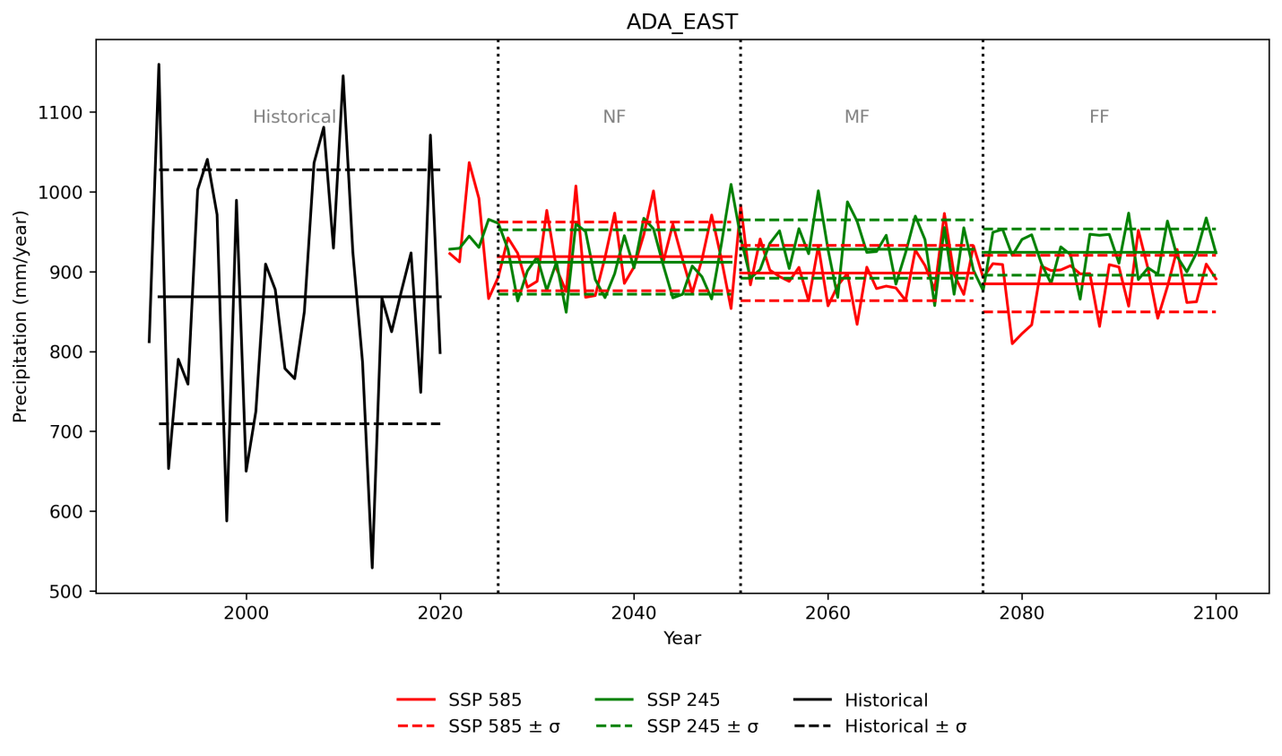
Figure 23: Yearly RainfallTrend (Downscaled)
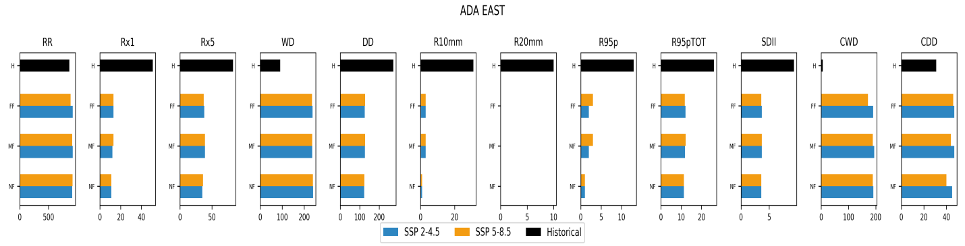
Figure 24: Precipitation indices trend (RR, Rx1, Rx5, R20mm, R95p, CDD, CWD, etc.)
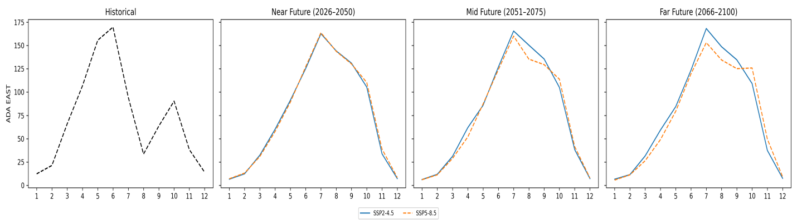
Figure 25: Monthly cycle of rainfall projections

Temperature projections indicate a consistent warming trend. Historically, average annual temperatures in Ada East were around 26.5°C. Under SSP2-4.5, warming of 1.5–2.0°C is expected by mid-century, while SSP5-8.5 could lead to increases of up to 3.5–4.0°C by 2100. The frequency of hot days (TX90p) and warm nights (TN90p) is projected to rise significantly, with associated impacts on human health, water resources and crop productivity. Conversely, the number of cool days (TX10p) and cool nights (TN10p) is projected to decline sharply, highlighting the dominance of warming extremes.
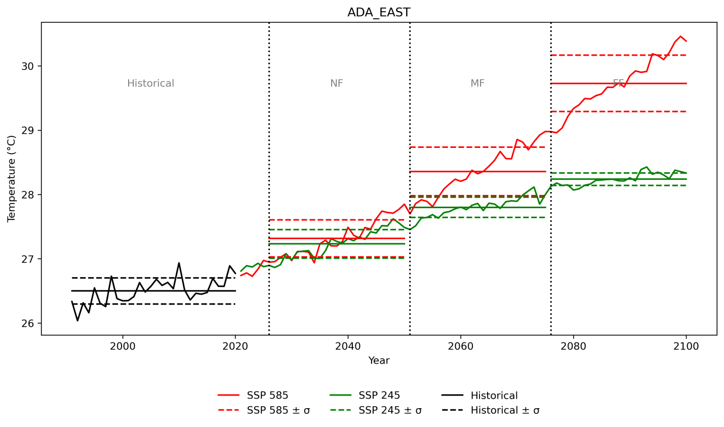
Figure 26: Yearly Temperature Trend (Downscaled)
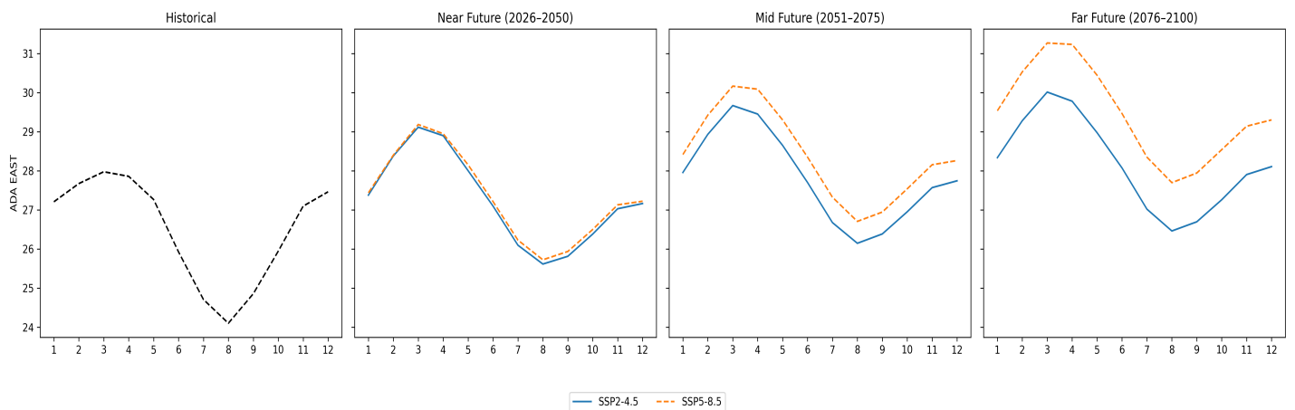
Figure 27: Monthly cycle of temperature projections
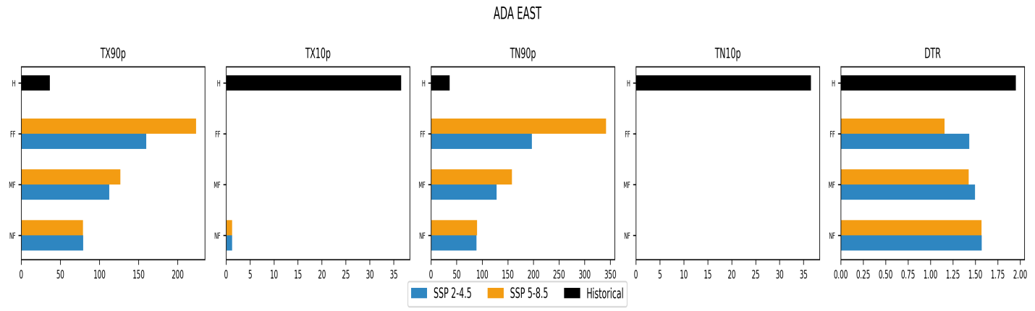
Figure 28: Temperature indices (TX90p, TX10p, TN90p, TN10p, DTR)

4.1.5 Summary of Climate Change Projections
Overall, Ada East District faces a future marked by rising temperatures, more frequent heat extremes, and increasingly variable rainfall patterns. While total rainfall may not decline significantly, its distribution is expected to become more erratic, increasing the risk of both intense flooding and prolonged dry spells. Sea-level rise and tidal influences will further exacerbate these hazards, particularly in coastal and low-lying communities. The combined effects of hotter conditions and unpredictable rainfall are likely to impact agriculture, fisheries, health, and water security. Adaptation planning for Ada East must therefore prioritize climate-resilient infrastructure, enhanced water management, and livelihood diversification, while explicitly addressing the gendered dimensions of climate vulnerability.

4.2 Potential Impacts and Future Climate Change Risk
Ada East faces significant climate risks across multiple sectors, driven by rising temperatures, erratic rainfall, and sea-level rise. Key priority risk domains include agriculture and food security, water resources, coastal ecosystems, health, infrastructure, and the dual threats of flooding and drought, which are expected to intensify under climate change.
4.2.1 Agriculture
Agriculture in Ada East is highly vulnerable due to its dependence on rain-fed systems. Erratic rainfall, delayed onset, early cessation, and prolonged dry spells disrupt growing seasons for staple crops such as maize, cassava, and vegetables. Rising temperatures further reduce yields, exacerbating food insecurity and economic instability (EPA, 2021). Sea-level rise and intensified rainfall increase flooding and saltwater intrusion, degrading soil quality and reducing fertility. Salinization alters microbial activity, soil enzyme function, and greenhouse gas emissions, with severe salinity potentially reducing crop yields by up to 58% (Haj-Amor et al., 2022; Xiao et al., 2021). Prolonged heat and humidity also encourage pest and disease outbreaks, increasing pesticide use and production costs (Ankrah, 2024). Overall, these factors combine to threaten agricultural productivity and household food security.
4.2.2 Water Resources
Water availability in Ada East is under increasing pressure from drought, flooding, and saltwater intrusion. Dry spells reduce surface and groundwater, while intense rainfall contaminates water supplies and strains sanitation systems (Ghana Meteorological Agency, 2020). Coastal saltwater intrusion further compromises potable water, raising treatment costs. Inland communities face over-extraction and drying wells, while coastal fishing and agricultural communities report declining water quality affecting irrigation and livelihoods (Sarku, 2023; Mattah et al., 2024).
4.2.3 Human Health
Flooding and drought pose significant health risks. Floods contaminate water sources, spreading cholera, diarrhoea, and other waterborne diseases (Ministry of Health, 2020; Hussey & Arku, 2019). Drought reduces water for hygiene, increasing risks of typhoid and malaria. Rising temperatures and humidity facilitate vector-borne diseases such as malaria and dengue (Chandra & Mukherjee, 2021; Tidman et al., 2021). Climate impacts on food production exacerbate malnutrition, particularly among vulnerable groups like children, the elderly, and outdoor workers (Mekonnen et al., 2021; Issahaku et al., 2023).
4.2.4 Infrastructure
Ada East’s low-lying geography and coastal position expose infrastructure to floods, erosion, and sea-level rise. Roads, bridges, homes, schools, and health facilities are increasingly at risk, particularly in areas like Big Ada and Ada Foah (Tumawu et al., 2024; EPA, 2021). Drought further stresses water supply systems, undermining urban and agricultural infrastructure. These combined impacts disrupt mobility, service delivery, and local economies, forcing coping strategies such as temporary migration.
4.2.5 Forestry and Biodiversity
Forests and aquatic ecosystems are critical for livelihoods and climate buffering but are under pressure from rising temperatures, droughts, and tidal surges. Mangrove forests along the Songor Lagoon and Volta estuary protect against coastal erosion and provide fish breeding grounds, yet are rapidly degrading due to fuelwood harvesting, charcoal production, and unregulated land use. Rising salinity and extreme weather hinder regeneration, while vegetation loss reduces carbon sequestration, ecosystem services, and biodiversity. Declining fish and crab stocks compromise food security and incomes, while limited restoration initiatives remain insufficient to counter ecosystem degradation.
4.2.6 Gendered Vulnerability
Gender dynamics significantly shape climate vulnerability in Ada East. Women play central roles in agriculture, water collection, and fish processing but face disproportionate risks due to limited decision-making power, restricted access to credit, and minimal institutional support. Floods and saltwater intrusion directly impact women’s livelihoods, while water scarcity and increased caregiving responsibilities reduce time for economic activities or education, particularly for young girls. Women’s exclusion from adaptation planning limits the integration of their knowledge and needs, weakening household and community resilience.
Climate change in Ada East will disproportionately affect coastal and low-lying communities, rain-fed farmers, and women due to intersecting environmental, economic, and social vulnerabilities. Effective adaptation requires integrated strategies, including climate-resilient infrastructure, improved water and sanitation management, ecosystem restoration, livelihood diversification, and gender-responsive policies to strengthen adaptive capacity and reduce inequities across sectors and populations.

CHAPTER 5 – IMPLICATIONS FOR ADAPTATION PLANNING

5.1 Introduction
The results of the vulnerability and risk assessment for Ada East highlight the urgency of developing a robust, gender-responsive and community-driven adaptation strategy. Climate hazards in the district including flooding, tidal surges, saltwater intrusion and drought, intersect with socio-economic conditions such as poverty, weak infrastructure and limited institutional capacity, creating multi-layered vulnerabilities. Effective adaptation planning must therefore move beyond sectoral responses to adopt an integrated approach that addresses systemic risks, strengthens adaptive capacity and ensures social inclusion.
Strengthening Climate-Resilient Livelihoods
Agriculture, fisheries and salt mining, the backbone of Ada East’s economy, are highly climate-sensitive. Flooding and tidal surges damage farmlands, while saltwater intrusion undermines crop productivity and freshwater availability. Similarly, declining fish stocks linked to changing tidal regimes directly threaten food security and incomes. Adaptation planning should prioritize climate-smart agriculture, including drought-tolerant crop varieties, improved irrigation systems and soil conservation measures. For fisheries, sustainable resource management, aquaculture diversification and investment in fish processing infrastructure will reduce sensitivity to climatic shocks. Salt mining requires improved water management systems and early warning mechanisms to mitigate losses from unseasonal rains.
Addressing Water Insecurity
Survey findings showed that significant proportions of communies in Ada East struggle with accessing potable water, with many communities spending significant amounts on water due to scarcity and saline intrusion. Adaptation planning must therefore prioritize water security through investments in safe water supply infrastructure, expansion of the District Water Supply Scheme and rainwater harvesting systems. Integrating climate projections into water resource management will be essential for balancing domestic, agricultural and industrial demands.
Building Climate-Resilient Infrastructure
Poor drainage systems, weak sea defenses and unregulated construction in flood-prone zones are compounding climate risks in Ada East. Coastal erosion has already claimed over 120 hectares of land, while flooding has displaced thousands of residents in recent years. Adaptation strategies should focus on completing and maintaining sea defense projects, upgrading drainage networks and enforcing land-use planning regulations. Infrastructure investments should incorporate climate risk screening to ensure long-term resilience of roads, schools, markets and health facilities.
Enhancing Public Health Preparedness
Floods and stagnant waters have triggered recurrent outbreaks of cholera, malaria and typhoid, stretching the limited capacity of local health facilities. Adaptation planning must invest in disease surveillance systems, climate-sensitive health infrastructure and WASH (Water, Sanitation and Hygiene) programs. Community-based awareness campaigns, early warning for disease outbreaks and improved sanitation facilities, especially in coastal settlements without toilets will help reduce health sensitivity.
Promoting Ecosystem-Based Adaptation
The decline of mangrove ecosystems around the Songor Lagoon and Volta River estuary removes critical natural buffers against tidal surges and erosion. Adaptation planning should prioritize mangrove restoration, afforestation and conservation of wetlands as cost-effective, ecosystem-based approaches that deliver both ecological and livelihood benefits. Community participation in these initiatives will ensure sustainability while generating alternative income streams through eco-tourism and sustainable harvesting.
Mainstreaming Gender and Social Inclusion
The survey data revealed stark gender inequalities in adaptation capacity: while men dominate financial and farming decisions, women bear the heaviest workloads in water collection, childcare and fish processing, yet have less than 10% equal access to credit and virtually no organizational support for adaptation. Adaptation planning must mainstream gender by creating women-centered organizations, ensuring equal access to land and credit and tailoring interventions to reduce women’s disproportionate burdens. Social protection measures should also target persons with disabilities and marginalized groups who face discrimination in accessing livelihood opportunities.
Strengthening Institutional Capacity and Governance
Adaptation planning requires well-coordinated institutions at the district and community levels. Current gaps in enforcement of coastal buffer zones, weak early warning dissemination and fragmented institutional roles undermine resilience. Building adaptive governance will require strengthening NADMO’s capacity, integrating climate risk into district development plans, enhancing coordination across ministries and investing in community-based early warning systems.
Towards Integrated Adaptation Pathways
The evidence from Ada East underscores that adaptation cannot be treated as a set of isolated interventions. Instead, it must be pursued through integrated pathways that link resilient livelihoods, water security, ecosystem protection, gender equity and institutional strengthening. By embedding these priorities into the District Medium-Term Development Plan and aligning them with Ghana’s National Adaptation Plan (NAP), Ada East can transition from reactive crisis management to proactive resilience building.

5.2 Conclusions
The vulnerability assessment of Ada East District demonstrates that exposure to climate change is multi-dimensional, encompassing physical, socio-economic, gendered, and institutional factors. Rising temperatures, more frequent heat extremes, erratic rainfall patterns, and sea-level rise are already affecting the district’s coastal, estuarine, and inland communities. When these hazards intersect with structural challenges—such as reliance on climate-sensitive livelihoods, inadequate infrastructure, environmental degradation, limited institutional capacity, and social inequalities they create a complex web of risks that threaten food security, water access, human health, livelihoods, and ecosystem services.
Adaptation planning in Ada East must move beyond reactive, short-term measures. The findings underscore the need for anticipatory, inclusive, and integrated adaptation strategies that are aligned with local development priorities and consistent with national frameworks, including Ghana’s National Adaptation Plan (NAP). Strengthening resilience will require not only climate-smart infrastructure and livelihood interventions but also robust governance systems, empowered communities, and reliable financing mechanisms.
Strategic entry points include promoting climate-resilient agriculture, improving water and sanitation management, restoring coastal and inland ecosystems such as mangroves and wetlands, enhancing infrastructure to withstand floods and droughts, strengthening health systems, and mainstreaming gender- and youth-responsive approaches to livelihood support. These actions should be embedded into district planning and service delivery, ensuring that adaptation becomes a core component of development rather than a separate initiative.
The long-term vision for Ada East is a climate-resilient district where coastal and inland communities are protected from flooding, tidal surges, and salinization; where farming, fisheries, and other livelihoods are sustained despite climatic pressures; where ecosystems continue to provide essential services; and where institutions proactively manage climate risks in an inclusive manner. Achieving this vision will require strong partnerships among government agencies, traditional authorities, civil society, the private sector, and development partners, as well as the active engagement of women, men, youth, and marginalized groups, ensuring that resilience-building efforts are equitable and leave no one behind.

REFERENCES
- Abu, M., Atiglo, D. Y., Addoquaye Tagoe, C., & Codjoe, S. N. (2022). Drivers of migration intentions in the Volta Delta: Investigating the effect of climate-related hazards and adaptation strategies. Frontiers in Climate, 4, 975650.
- Adaawen, S. (2021). Understanding climate change and drought perceptions, impact and responses in the rural Savannah, West Africa. Atmosphere, 12(5), 594.
- Addo, K. A., Jayson-Quashigah, P.-N., & Kufogbe, S. K. (2020). Shoreline changes and their socioeconomic impacts on coastal communities in Ghana. Journal of Coastal Conservation, 24(1), 1–12. https://doi.org/10.1007/s11852-019-00710-0
- Agodzo, S. K., Bessah, E., & Nyatuame, M. (2023). A review of the water resources of Ghana in a changing climate and anthropogenic stresses. In Frontiers in Water (Vol. 4). Frontiers Media S.A. https://doi.org/10.3389/frwa.2022.973825
- Akpalu, W., & Codjoe, S. N. A. (2013). Economic analysis of climate variability impact on malaria prevalence: The case of Ghana. Sustainability, 5(10), 4362–4378. https://doi.org/10.3390/SU5104362
- Alongi, D. M. (2008). Mangrove forests: Resilience, protection from tsunamis and responses to global climate change. Estuarine, Coastal and Shelf Science, 76(1), 1–13. https://doi.org/10.1016/j.ecss.2007.08.024
- Andoh, H., & Kaba, J. S. (2025). Assessment and projection of climate change impact on Ghana’s agricultural crops: evidence from cassava (Manihot esculenta) production in the coastal Savannah agroecological zone. Theoretical and Applied Climatology, 156. https://doi.org/10.1007/s00704-025-05428-9
- Angnuureng, D. B., Ofosu, G. T., Ayimbisa, E. A., & Almar, R. (2024). Evaluating the Consequences of the 2023 Akosombo Dam Spillage into the Volta River on Fuveme Beach, Ghana (West Africa). Journal of Coastal Research, 113(sp1). https://doi.org/10.2112/jcr-si113-200.1
- Ankrah, J. (2024). Climate risks and adaptation strategies: the perspectives of farmers in coastal Ghana. Journal of Environmental Studies and Sciences. https://doi.org/10.1007/s13412-024-00970-w
- Appeaning Addo, K. (2013). Coastal erosion management in Ghana: Policy and practice. In W. Leal Filho (Ed.), Climate Change and the Sustainable Use of Water Resources (pp. 131–143). Springer. https://doi.org/10.1007/978-3-642-22266-5_9
- Asuamah-Tawiah, A. (2024). The Effects of Fluvial Flooding on Livelihood Vulnerability in Central Tongu and Ada East Districts of Ghana. Https://Repository.Ensign.Edu.Gh/Handle/123456789/242.
- Atiglo, D. Y., Abu, M., Jayson-Quashigah, P. N., Addo, K. A., & Ardey Codjoe, S. N. (2022). Sociodemographic and geophysical determinants of household vulnerability to coastal hazards in the Volta Delta, Ghana. International Journal of Disaster Risk Reduction, 78. https://doi.org/10.1016/j.ijdrr.2022.103146
- Avornyo, S. Y., Addo, K. A., Teatini, P., Minderhoud, P., Woillez, M. N., Jayson-Quashigah, P. N., & Mahu, E. (2023). A scoping review of coastal vulnerability, subsidence and sea level rise in Ghana: Assessments, knowledge gaps and management implications. Quaternary Science Advances, 12, 100108.
- Birkmann, J., Liwenga, E., Pandey, R., Boyd, E., Djalante, R., Gemenne, F., ... & Wrathall, D. (2022). Poverty, livelihoods and sustainable development.
- Boafo, Y. A., Lah, G. S., & Manteaw, B. O. (2025). Wetlands as nature-based solutions to climate-induced coastal hazards: Institutional perspectives from the Keta Lagoon Complex, Ghana. Wetlands Ecology and Management, 33(4), 60.
- Boafo, Y. A., Ohemeng, F. N. A., Ayivor, J., Ayitiah, J. A., Yirenya-Tawiah, D., Mensah, A., Datsa, C., Annang, T. Y., & Adom, L. (2024). Unraveling diarrheal disease knowledge, understanding and management practices among climate change vulnerable coastal communities in Ghana. Frontiers in Public Health, 12. https://doi.org/10.3389/fpubh.2024.1352275
- Boateng, I. (2012). An application of GIS and coastal geomorphology for large-scale assessment of coastal erosion and management: A case study of Ghana. Journal of Coastal Conservation, 16(3), 383–397. https://doi.org/10.1007/s11852-012-0209-0
- Bolle, A., das Neves, L., & Rooseleer, J. (2015). Coastal protection for Ada, Ghana: a case study. 168(3), 125–133. https://doi.org/10.1680/JMAEN.15.00013
- Chandra, G., & Mukherjee, D. (2021). Effect of climate change on mosquito population and changing pattern of some diseases transmitted by them. In Advances in Animal Experimentation and Modeling: Understanding Life Phenomena (pp. 455–460). Elsevier. https://doi.org/10.1016/B978-0-323-90583-1.00030-1
- CSIR–Water Research Institute (CSIR-WRI). (2018). Assessment of groundwater salinity and its impacts on coastal communities in Ada East District. Accra: Council for Scientific and Industrial Research.
- Cudjoe, S., & Kwabla Alorvor, S. (2021). Indigenous Knowledge Practices and Community Adaptation to Coastal Flooding in Ada East District of Ghana. Hydrology, 9, 13. https://doi.org/10.11648/j.hyd.20210901.12
- DeGroot, D. W., O’Connor, F. G., & Roberts, W. O. (2022). Exertional heat stroke: an evidence based approach to clinical assessment and management. In Experimental Physiology (Vol. 107, pp. 1172–1183). John Wiley and Sons Inc. https://doi.org/10.1113/EP090488
- Desjonqueres, C., Zhao, H., Kosmidou-Bradley, W., & Corral, P. (2024). Ghana’s climate vulnerability profile.
- Dharmarathne, G., Waduge, A. O., Bogahawaththa, M., Rathnayake, U., & Meddage, D. P. P. (2024). Adapting cities to the surge: A comprehensive review of climate-induced urban flooding. Results in Engineering, 22. https://doi.org/10.1016/j.rineng.2024.102123
- Dodman, D., Sverdlik, A., Agarwal, S., Kadungure, A., Kothiwal, K., Machemedze, R., & Verma, S. (2023). Climate change and informal workers: Towards an agenda for research and practice. Urban Climate, 48, 101401. https://doi.org/10.1016/j.uclim.2022.101401
- Environmental Protection Agency (EPA). (2021). Ghana’s Fourth National Communication to the UNFCCC: Climate Change Impacts, Vulnerabilities and Adaptation Assessments. Accra: Ministry of Environment, Science, Technology and Innovation.
- EPA. (2020). Ghana’s Fourth National Communication to the United Nations Framework Convention on Climate Change. https://unfccc.int/sites/default/files/resource/Gh_NC4.pdf
- Fianko, J. R., & Dodd, H. S. (2019). Investigation of the factors that contribute to degradation of Songor Ramsar and UNESCO Man and Biosphere Reserve in Ghana. West African Journal of Applied Ecology, 27(2), 126–136. https://doi.org/10.4314/WAJAE.V27I2
- Fowler, H. J., & Ali, H. (2022). Analysis of extreme rainfall events under the climatic change. In Rainfall: Modeling, Measurement and Applications (pp. 307–326). Elsevier. https://doi.org/10.1016/B978-0-12-822544-8.00017-2
- Ghana Business News. (2022, April 5). Tidal waves displace hundreds in Ada East. https://www.ghanabusinessnews.com/2022/04/05/tidal-waves-displace-hundreds-in-ada-east/
- Ghana Meteorological Agency (GMet). (2020). Climate data summary and projections for Ghana: 1960–2019. Accra: Ghana Meteorological Agency.
- Ghana News Agency (GNA). (2024, April 18). Over 100 homes submerged by river waves in Ada East. https://www.gna.org.gh/
- Ghana Statistical Service (2021). 2021 Population and Housing Census: Ada East District Analytical Report.
- Ghana Statistical Service. (2021). GHANA 2021 POPULATION AND HOUSING CENSUS: LITERACY AND EDUCATION.
- Ghana Web. (2024, June 12). Mangrove loss worsening flood risk in Ada East District. https://www.ghanaweb.com/
- Haj-Amor, Z., Araya, T., Kim, D. G., Bouri, S., Lee, J., Ghiloufi, W., Yang, Y., Kang, H., Jhariya, M. K., Banerjee, A., & Lal, R. (2022). Soil salinity and its associated effects on soil microorganisms, greenhouse gas emissions, crop yield, biodiversity and desertification: A review. In Science of the Total Environment (Vol. 843). Elsevier B.V. https://doi.org/10.1016/j.scitotenv.2022.156946
- Hussey, L. K., & Arku, G. (2019). Conceptualizations of climate-related health risks among health experts and the public in Ghana. Social Science and Medicine, 223, 40–50. https://doi.org/10.1016/j.socscimed.2019.01.026
- Intergovernmental Panel on Climate Change (IPCC). (2021). Climate change 2021: The physical science basis. Contribution of Working Group I to the Sixth Assessment Report of the Intergovernmental Panel on Climate Change. Cambridge University Press. https://www.ipcc.ch/report/ar6/wg1/
- Issahaku, D., Manteaw, B. O., & Wrigley-Asante, C. (2023). Climate change and food systems: Linking adaptive capacity and nutritional needs of low-income households in Ghana. PLOS Climate, 2, e0000154. https://doi.org/10.1371/journal.pclm.0000154
- Johnson, A. (2024). Assessing Climate Change and Climate Variability Impacts in the Coastal Savannah Agroecological Zone of Ghana (Doctoral dissertation, Universidade do Porto (Portugal)).
- Krair, S. S. A. (2020). Interference between sea water and groundwater. International Journal of Fauna and Biological Studies, 7(2), 46–57. http://www.faunajournal.com/archives/2020/vol7issue2/PartA/7-2-4-842.pdf
- Kuzor, A. (2024). Green Ghana Day: NGO, partners move to restore depleted mangroves in Ada. Https://Www.Ghanaweb.Com/GhanaHomePage/NewsArchive/Green-Ghana-Day-NGO-Partners-Move-to-Restore-Depleted-Mangroves-in-Ada-1935197?Utm_source=chatgpt.Com.
- Letsyo, E. (2025). Community-Based Approaches Towards Climate Resilience in the Effutu Municipality: Integrating Traditional Knowledge and Scientific Methods for Sustainable Adaptation. Climate Action in Ghana, 32.
- Makondo, C. C., & Thomas, D. S. (2024). Multidimensional poverty and vulnerability assessment in the face of climate change adaptation in developing economies: focus on ecosystem-based livelihoods in Zambia. Environment, Development and Sustainability, 1-47.
- Mattah, M. M., Mattah, P. A. D., Mensah, A. M., Adarkwah, F., Mensah, J., & Addo, K. A. (2024). Community perceptions, knowledge and coping mechanisms concerning perennial climate change-related disasters along the Volta estuary of Ghana, West Africa. Scientific African, 25. https://doi.org/10.1016/j.sciaf.2024.e02333
- Mekonnen, A., Tessema, A., Ganewo, Z., & Haile, A. (2021). Climate change impacts on household food security and farmers adaptation strategies. Journal of Agriculture and Food Research, 6. https://doi.org/10.1016/j.jafr.2021.100197
- Mensah, A. M., Amoani, Y., & Agyeman, Y. B. (2016). Assessing the role of mangroves in mitigating coastal hazards and supporting livelihoods in Ghana. Journal of Coastal Management, 44(3), 226–240. https://doi.org/10.1080/08920753.2016.1150879
- Ministry of Health. (2020). National climate change and health strategy: 2020–2030. Accra: Ministry of Health.
- Mohd, I., Bhat, F. A., Shah, T. H., & Wali, A. (2024). Consequence of climate change on fisheries and aquatic system (pp. 1–6). https://doi.org/10.58532/v3bcag18p1ch1
- MyJoyOnline. (2023, October 22). Akosombo Dam spillage displaces 5,685 in Ada East. https://www.myjoyonline.com/akosombo-dam-spillage-displaces-5685-in-ada-east/
- Osei, F. B., & Duker, A. A. (2008). Spatial dependency of V. cholera prevalence on open space refuse dumps in Kumasi, Ghana: A spatial statistical modelling. International Journal of Health Geographics, 7(1), 62. https://doi.org/10.1186/1476-072X-7-62
- Osei, S. (2024). Analyzing the intersection of climate vulnerability and household food insecurity in northern Ghana: a sustainable livelihoods approach (Doctoral dissertation, University of the Western Cape).
- Osman, B. (2023). Climate and food insecurity risks: identifying exposure and vulnerabilities in the post-food production system of northern ghana. Land, 12(11), 2025. https://doi.org/10.3390/land12112025
- Owusu-Daaku, K. (2017). The Sea Defense Project in Ada East District and its implications for Climate Change Policy Implementation in Ghana&#39;s Peri-urban Areas. Https://Www.Academia.Edu/32042233/The_Sea_Defense_Project_in_Ada_East_District_and_its_implications_for_Climate_Change_Policy_Implementation_in_Ghanas_Peri_urban_Areas?Utm_source=chatgpt.Com.
- Özer, E. (2024). Climate change and its impact on women’s living. Journal of Health Sciences and Medicine. https://doi.org/10.32322/jhsm.1481918
- Pienaah, C. K., Batung, E., Saaka, S. A., Mohammed, K., & Luginaah, I. (2023). Early warnings and perceived climate change preparedness among smallholder farmers in the Upper West Region of Ghana. Land, 12(10), 1944.
- Sarku, R. (2023). Farmers’ perspectives on water availability in the lower Volta Delta region in Ghana. Regional Environmental Change, 23. https://doi.org/10.1007/s10113-023-02152-w
- Serdeczny, O., Adams, S., Baarsch, F., Coumou, D., Robinson, A., Hare, W., ... & Reinhardt, J. (2017). Climate change impacts in Sub-Saharan Africa: from physical changes to their social repercussions. Regional Environmental Change, 17(6), 1585-1600.
- Sethamo, O. A., & Harder, M. K. (2021). Evaluating what matters: an evaluation tool for vulnerability risk assessments in local climate change adaptation planning. Journal of Environmental Planning and Management, 64(13), 2346-2364.
- Siakwah, P., Ablo, A. D., Sheburah-Essien, R., Zaami, M., & Yaro, J. A. (2025). Adapting to climate change amidst innovation diffusion and declining indigenous agricultural knowledge and practices in Ghana. African Journal of Science, Technology, Innovation and Development. https://doi.org/10.1080/20421338.2025.2459355
- Tarolli, P., Luo, J., Park, E., Barcaccia, G., & Masin, R. (2024). Soil salinization in agriculture: Mitigation and adaptation strategies combining nature-based solutions and bioengineering. Iscience, 27(2).
- Tidman, R., Abela-Ridder, B., & De Castañeda, R. R. (2021). The impact of climate change on neglected tropical diseases: A systematic review. In Transactions of the Royal Society of Tropical Medicine and Hygiene (Vol. 115, pp. 147–168). Oxford University Press. https://doi.org/10.1093/trstmh/traa192
- Townhill, B., Harrod, O., Painting, S., Acheampong, E., Bell, J., Nyarko, B. K., & Engelhard, G. (2023). Climate change risk and adaptation for fisher communities in Ghana. Journal of Coastal Conservation, 27(5), 45.
- Tumawu, A. F., Kafu, G. Y., Yiran, G. A. B., & Frimpong, L. K. (2024). Assessment of coastal flood risk scenarios on infrastructure in the Keta district in Ghana using a GIS approach. Heliyon, 10. https://doi.org/10.1016/j.heliyon.2024.e39824
- Tumawu, G., Agyemang, E., & Boateng, I. (2024). Coastal infrastructure vulnerability under sea-level rise scenarios in Ghana. Journal of Climate Resilience and Infrastructure, 12(1), 45–62
- United Nations Ghana (UN Ghana). (2025, March). Cholera outbreak situation report – Ghana. Accra: UN Ghana Country Office.
- West African Science Service Centre on Climate Change and Adapted Land Use (WASCAL). (2020). Climate scenarios for Ghana: Supporting policy and planning for adaptation. Accra: WASCAL.
- World Health Organization (WHO). (2023). Climate change and health country profile: Ghana. Geneva: World Health Organization. https://www.who.int/publications/i/item/WHO-Ghana-Climate-Health-Profile-2023
- Xiao, H., Tang, Y., Li, H., Zhang, L., Ngo-Duc, T., Chen, D., & Tang, Q. (2021). Saltwater intrusion into groundwater systems in the Mekong Delta and links to global change. In Advances in Climate Change Research (Vol. 12, pp. 342–352). National Climate Center. https://doi.org/10.1016/j.accre.2021.04.005
- Yeboah, F., Ackom, E. K., Yidana, S. M., & Awotwi, A. (2024). Hydrologic Modelling for Flood Threshold and Hazard Prediction in the Black Volta River Basin, West Africa. Environmental Modeling and Assessment, 29, 375–394. https://doi.org/10.1007/s10666-023-09946-6

APPENDICES

Appendice 1 – Matrix of Function
Towns/Village - ADA EAST
Total population of village tract/ward /

Category | Name of function | Presence |  | No. Available in town/village
Category | Name of function | Yes | No | 1-5 | 6-10 | 10+
1. Public utilities and facilities  . | 1.1. Access or connectivity | * |  |  |  | *
1. Public utilities and facilities  . | 1.2. Radio station/Access | * |  | *
1. Public utilities and facilities  . | 1.3. Post office. | * |  | *
1. Public utilities and facilities  . | 1.4. Rainwater harvest. | * |  |  |  | *
1. Public utilities and facilities  . | 1.5. Usable wells | * |  |  |  | *
 | 1.6. Pipe borne water. | * |  |  |  | *
 | 1.7. Irrigation system for farming. | * |  |  |  | *
 | 1.8. Private solar panel electricity supply. | * |  | *
 | 1.9. Public Electricity Network on Grid | * |  |  |  | *
 | 1.10. Sewerage drainage /gutters. | * |  | *
 | 1.11. Storm water drainage system/big gutters. |  | *
2. Road Connection and Transportation Infrastructure | 2.1. Paved/tarred roads. | * |  | *
2. Road Connection and Transportation Infrastructure | 2.2. Unpaved/untarred roads. | * |  |  |  | *
2. Road Connection and Transportation Infrastructure | 2.3. Public transportation daily basis. | * |  |  |  | *
2. Road Connection and Transportation Infrastructure | 2.4. Bus Station. | * |  |  |  | *
2. Road Connection and Transportation Infrastructure | 2.5. Petrol filling Station | * |  |  | *
3. Markets | 3.1. Local Market | * |  | *
3. Markets | 3.2. Livestock/fish Market |  | *

Category | Name of function | Presence |  | No. Available in town/village
Category | Name of function | Yes | No | 1-5 | 6-10 | 10+
4. Industries and Commercial Establishments | 4.1. Small basic needs stall | * |  |  |  | *
4. Industries and Commercial Establishments | 4.3. Big retail shop | * |  |  | *
4. Industries and Commercial Establishments | 4.4. Restaurant/chopbar | * |  |  |  | *
4. Industries and Commercial Establishments | 4.5. Hotel/guest house. | * |  |  |  | *
4. Industries and Commercial Establishments | 4.6. Bicycle Repair shop | * |  |  |  | *
 | 4.7. Fitting or auto mechanics shop | * |  |  |  | *
 | 4.8. Factory |  | *
 | 4.10. Aquaculture (Crabs, Shrimps) | * |  | *
 | 4.11. Financial services: Banks, western union, Momo access | * |  |  |  | *
5. Provisioning eco-systems services | 5.1. Rice farms. | * |  | *
5. Provisioning eco-systems services | 5.2. Grains |  | *
5. Provisioning eco-systems services | 5.3. Groundnuts. |  | *
5. Provisioning eco-systems services | 5.4. Maize. | * |  |  |  | *
5. Provisioning eco-systems services | 5.5. Beans. |  | *
5. Provisioning eco-systems services | 5.6. Flowers. | * |  | *
5. Provisioning eco-systems services | 5.7. Tobacco. |  | *
5. Provisioning eco-systems services | 5.8. Vegetables. | * |  |  |  | *
5. Provisioning eco-systems services | 5.9. Livestock. | * |  |  |  | *
5. Provisioning eco-systems services | 5.10. Wood for charcoal. | * |  | *
5. Provisioning eco-systems services | 5.11. Oil extraction. | * |  |  |  | *
5. Provisioning eco-systems services | 5.12. Herbal/Natural medicines. | * |  |  | *
6. Health Facilities | 6.1. CHIP Compound. | ** |  |  | *
6. Health Facilities | 6.2. Public Hospital. | * |  | *
6. Health Facilities | 6.3. Clinic. | * |  | *
7. Specialized Health Staff and Services | 7.1 Midwife (government/traditional). | * |  | *
7. Specialized Health Staff and Services | 7.2 Dentist | * |  | *
7. Specialized Health Staff and Services | 7.3 Eye specialist. | * |  | *
7. Specialized Health Staff and Services | 7.4. Pharmacy. | * |  |  |  | *

Category | Name of function | Presence |  | No. Available in town/village
8. Educational Institutions | 8.1. Kindergarten. | Yes | No | 1-5 | 6-10 | 10+
8. Educational Institutions | 8.2. Basic Education Primary Schools. | * |  |  |  | *
8. Educational Institutions | 8.3. Basic Junior High Schools. | * |  |  |  | *
8. Educational Institutions | 8.4. Senior High Schools. | * |  |  |  | *
8. Educational Institutions | 8.6. Vocational/Technical Training Schools. | * |  | *
 | 8.7. University/Colleges of Education. | * |  | *
9. Public  recreational  and Cultural  Facilities | 91. Cultural Centre. | * |  | *
9. Public  recreational  and Cultural  Facilities | 9.2. Museum. | * |  | *
9. Public  recreational  and Cultural  Facilities | 9.3. Library. | * |  | *
10. Security Services | 10.1. Disaster management organisation . | * |  | *
10. Security Services | 10.2. Police Check Point . | * |  | *
10. Security Services | 10.3. Police Station . | * |  | *
10. Security Services | 10.4. Fire Station . | * |  | *
10. Security Services | 10.5 Disaster evacuation point | * |  | *
11. Community Organizations and NGOs | 11.1. Churches/Mosques | * |  |  |  | *
11. Community Organizations and NGOs | 11.2. Civil Society Organisation | * |  |  | *
11. Community Organizations and NGOs | 11.3. Cooperative Union | * |  |  | *
11. Community Organizations and NGOs | 11.4. NGOs | * |  |  |  | *
12. Own account worker | 12.1. Fishermen | * |  |  |  | *
12. Own account worker | 12.2. Street sellers | * |  |  |  | *
12. Own account worker | 12.3. Carpenters | * |  |  |  | *
12. Own account worker | 12.4. Weaving/sewing | * |  |  |  | *
12. Own account worker | 12.5. Lawyers | * |  | *
12. Own account worker | 12.6. Accountants
12. Own account worker | 12.7. Licensed Electricians
12. Own account worker | 12.8. Plumbers .

Appendix 2 – Variables for LVI
Variable | MAIN COMPONENT | IPCC COMPONENT
% Respondents with no Education | Sociodemographic profile | Adaptive Capacity
% Unemployed |  | Adaptive Capacity
% Not engaged in any secondary occupation | Livelihood strategies | Adaptive Capacity
% Households with agriculture as only source of income |  | Adaptive Capacity
% Households with civil or government as only source of income |  | Adaptive Capacity
% Households with private sector (business) as only source of income |  | Adaptive Capacity
% Households with fishing as only source of income |  | Adaptive Capacity
%Households without member working outside community |  | Adaptive Capacity
% Not dependent on ecosytem services |  | Adaptive Capacity
% Not obtaining income from the forestry sector |  | Adaptive Capacity
% Farmers not growing 1 more crop |  | Adaptive Capacity
% Farmers not rearing livestock |  | Adaptive Capacity
% that have left due to climate/environmental changes in last 5 years? |  | Adaptive Capacity
% Interested in agricultural insurance but cannot afford |  | Adaptive Capacity
% Not suscribed to agricultural insurance |  | Adaptive Capacity
% Respondents not part of any social group | Social network | Adaptive Capacity
% Not aware of any gender association or organisation in their community |  | Adaptive Capacity
% of communities without there any gender related government social interventions (e.g., LEAP, s |  | Adaptive Capacity
% who have never received support from any Research and Development Institution |  | Adaptive Capacity
% who have never received support from any NGO or CSO |  | Adaptive Capacity
% who have never received support from any Government Organisation |  | Adaptive Capacity
% without access to credit |  | Adaptive Capacity
% Without access to remittances from family or friends |  | Adaptive Capacity
% Without access to subsidies |  | Adaptive Capacity
% Farmers not associated with any Farmer Based Organization (FBO) |  | Adaptive Capacity
% Farmers not associated with any Agriculture Extention Agent (AEA) |  | Adaptive Capacity
% Farmers without irrigation (rainfall dependent) |  | Adaptive Capacity
% Farmers without access to information on production methods and systems |  | Adaptive Capacity
% Without knowledge about agricultural insurance |  | Adaptive Capacity
Size of farm (acres) |  | Adaptive Capacity
 |  | Sensitivity
% Without a health facility in their communities | Health | Sensitivity
Minutes of travel to the nearest health facilities |  | Sensitivity
Number of health facilities in the community |  | Sensitivity
% Without the NHIS |  | Sensitivity
% Households where a member missed work/school due to illness |  | Sensitivity
% Without access to safe sanitation services |  | Sensitivity
Number of public toilet facilitites in the community |  | Sensitivity
% Without training/sensitization on climate related diseases |  | Sensitivity
% of nearest hospitals that have been affected by floods/storm damage/droughts |  | Sensitivity
% whose houses or infrastructure been damanged by flood, erosion or strong winds in the past 5 years | Infrastructure | Sensitivity
% affected by road block or unusable roads during rains |  | Sensitivity
% without disaster resilient infrastructure |  | Sensitivity
% without access to ready market |  | Sensitivity
% without access to good road network |  | Sensitivity
% With dealing with persistent water source unavailability | Water | Sensitivity
% Without access to potable water |  | Sensitivity
Average cost of water per month |  | Sensitivity
% Households without water source being available everyday |  | Sensitivity
Average minutes to get to a water source not inside the household |  | Sensitivity
% Conflicts about water sources in the community |  | Sensitivity
Proportion of farm under irrigation | Agriculture | Sensitivity
% Farmers without access to water for dry season farming |  | Sensitivity
Average of Total output lost as post-harvest loses |  | Sensitivity
% without access to coastsl storm warnings | Coastal | Sensitivity
% 1 km or less from shoreline |  | Sensitivity
% house considered relocating due to sea-related risk |  | Sensitivity
% Service worker respondents mostly dependent on household farms for food | Service | Sensitivity
% Respondents' businesses without insurance |  | Sensitivity
% Dependent on agricultural raw products for their activity |  | Sensitivity
% Business persons not aware government support for their business |  | Sensitivity
% Not aware of climate driven risks | DRR | Sensitivity
% Respondents who received no warnings to extreme weather |  | Sensitivity
% that does not recieve information of weather information for your communication devices |  | Sensitivity
Extreme Droughts in respective communities | Natural disasters | Exposure
Extreme Floods in respective communities |  | Exposure
% Farmers with farms in flood prone areas |  | Exposure
% service businesses in flood prone areas |  | Exposure
% affected by forest pest and disease outbreak |  | Exposure
Number of forest fires have occurred in this community since 10 years ago |  | Exposure
% that have been affected by shoreline erosion, accretion or both |  | Exposure
% household affected by tidal flooding |  | Exposure
% affected by saltwater intrusion |  | Exposure
% fall in fish catch over past 10 years |  | Exposure
Mean annual rainfall | Climate variability | Exposure
Annual minimum temperature |  | Exposure
Annual maximum temperature |  | Exposure
Average number of Consecutive Dry Days (CDD) |  | Exposure
Average number of Consecutive Wet Days (CWD) |  | Exposure

Appendix 3 – Sectoral LVI Variables
Variable | Component | Count of Variables
Health Sector | Component | Count of Variables
% Respondents with no Education | Sociodemographic | 2
% Unemployed
% Not engaged in any secondary occupation | Livelihood Strategies | 6
% Households with civil or government as only source of income
% Households with private sector (busisness) as only source of income
%Households without member working outside community
% Not dependent on ecosytem services
% that have left due to climate/environmental changes in last 5 years?
% Respondents not part of any social group | Social Network | 9
% Not aware of any gender association or organisation in their community
% of communities without there any gender related government social interventions (e.g., LEAP, s
% who have never received support from any Research and Development Institution
% who have never received support from any NGO or CSO
% who have never received support from any Government Organisation
% without access to credit
% Without access to remittances from family or friends
% Without access to subsidies | Adaptation Capacity | 17
% Without a health facility in their communities | Health Services | 5
Minutes of travel to the nearest health facilities
Number of health facilities in the community
% Without the NHIS
% Households where a member missed work/school due to illness
% whose houses or infrastructure been damanged by flood, erosion or strong winds in the past 5 years | Infrastructure for Healthcare | 4
% affected by road block or unusable roads during rains
% without disaster resilient infrastructure
% without access to good road network
% without access to coastsl storm warnings | Coastal factor | 3
% 1 km or less from shoreline
% house considered relocating due to sea-related risk
% Without access to safe sanitation services | Sanitation | 3
Number of public toilet facilitites in the community
% Without training/sensitization on climate related diseases | Sensitivity | 15
Extreme Droughts in respective communities | Climate hazzards and disasters | 7
Extreme Floods in respective communities
% affected by forest pest and disease outbreak
Number of forest fires have occurred in this community since 10 years ago
% that have been affected by shoreline erosion, accretion or both
% household affected by tidal flooding
% affected by saltwater intrusion
Mean annual rainfall | Climate change | 5
Annual minimum temperature
Annual maximum temperature
Average number of Consecutive Dry Days (CDD)
Average number of Consecutive Wet Days (CWD) | Exposure | 12
Infrastructure and Housing Sector
% Respondents with no Education | Sociodemographic | 2
% Unemployed
% Not engaged in any secondary occupation | Livelihood Strategie
% Households with civil or government as only source of income |  | 6
% Households with private sector (busisness) as only source of income
%Households without member working outside community
% Not dependent on ecosytem services
% that have left due to climate/environmental changes in last 5 years?
% Respondents not part of any social group | Social Network | 9
% Not aware of any gender association or organisation in their community
% of communities without there any gender related government social interventions (e.g., LEAP, s
% who have never received support from any Research and Development Institution
% who have never received support from any NGO or CSO
% who have never received support from any Government Organisation
% without access to credit
% Without access to remittances from family or friends
% Without access to subsidies | Adaptation Capacity | 17
% without access to coastal storm warnings | Coastal factor | 3
% 1 km or less from shoreline
% house considered relocating due to sea-related risk
% Without a health facility in their communities | Health and sanitation infrastructure | 4
Number of health facilities in the community
% Without access to safe sanitation services
Number of public toilet facilitites in the community
% whose houses or infrastructure been damanged by flood, erosion or strong winds in the past 5 years | Infrastructure | 5
% affected by road block or unusable roads during rains
% without disaster resilient infrastructure
% without access to ready market
% without access to good road network | Sensitivity | 12
Extreme Droughts in respective communities | Climate hazzards and disasters | 5
Extreme Floods in respective communities
% that have been affected by shoreline erosion, accretion or both
% household affected by tidal flooding
% affected by saltwater intrusion
Mean annual rainfall | Climate change | 5
Annual minimum temperature
Annual maximum temperature
Average number of Consecutive Dry Days (CDD)
Average number of Consecutive Wet Days (CWD) | Exposure | 10
Water Resources
% Respondents with no Education | Sociodemographic | 2
% Unemployed
% Not engaged in any secondary occupation | Livelihood Strategie | 6
% Households with civil or government as only source of income
% Households with private sector (busisness) as only source of income
%Households without member working outside community
% Not dependent on ecosytem services
% that have left due to climate/environmental changes in last 5 years?
% Respondents not part of any social group | Social Network | 9
% Not aware of any gender association or organisation in their community
% of communities without there any gender related government social interventions (e.g., LEAP, s
% who have never received support from any Research and Development Institution
% who have never received support from any NGO or CSO
% who have never received support from any Government Organisation
% without access to credit
% Without access to remittances from family or friends
% Without access to subsidies | Adaptation Capacity | 17
% With dealing with persistent water source unavailability | Household water use | 6
% Without access to potable water
Average cost of water per month
% Households without water source being available everyday
Average minutes to get to a water source not inside the household
% Conflicts about water sources in the community
% without access to coastsl storm warnings | Coastal factor | 3
% 1 km or less from shoreline
% house considered relocating due to sea-related risk
Proportion of farm under irrigation | Farm water use | 2
% Farmers without access to water for dry season farming | Sensitivity
 |  | 11
Extreme Droughts in respective communities | Climate hazzards and disasters | 7
Extreme Floods in respective communities
% affected by forest pest and disease outbreak
Number of forest fires have occurred in this community since 10 years ago
% that have been affected by shoreline erosion, accretion or both
% household affected by tidal flooding
% affected by saltwater intrusion
Mean annual rainfall | Climate change | 5
Annual minimum temperature
Annual maximum temperature
Average number of Consecutive Dry Days (CDD)
Average number of Consecutive Wet Days (CWD) | Exposure | 12
Agriculture and Food Security
% Respondents with no Education | Sociodemographic | 2
% Unemployed
% Not engaged in any secondary occupation | Livelihood Strategie | 13
% Households with agriculture as only source of income
% Households with civil or government as only source of income
% Households with private sector (busisness) as only source of income
% Households with fishing as only source of income
%Households without member working outside community
% Not dependent on ecosytem services
% Not obtaining income from the forestry sector
% Farmers not growing 1 more crop
% Farmers not rearing livestock
% that have left due to climate/environmental changes in last 5 years?
% Interested in agricultural insurance but cannot afford
% Not suscribed to agricultural insurance
% Respondents not part of any social group | Social Network | 15
% Not aware of any gender association or organisation in their community
% of communities without there any gender related government social interventions (e.g., LEAP, s
% who have never received support from any Research and Development Institution
% who have never received support from any NGO or CSO
% who have never received support from any Government Organisation
% without access to credit
% Without access to remittances from family or friends
% Without access to subsidies
% Farmers not associated with any Farmer Based Organization (FBO)
% Farmers not associated with any Agriculture Extention Agent (AEA)
% Farmers without irrigation (rainfall dependent)
% Farmers without access to information on production methods and systems
% Without knowledge about agricultural insurance
Size of farm (acres) | Adaptation Capacity | 30
Proportion of farm under irrigation | Food prodution | 3
% Farmers without access to water for dry season farming
Average of Total output lost as post-harvest loses
% With dealing with persistent water source unavailability | Water for agriculture and agriculture households | 6
% Without access to potable water
Average cost of water per month
% Households without water source being available everyday
Average minutes to get to a water source not inside the household
% Conflicts about water sources in the community
% without access to coastsl storm warnings | Coastal factor | 3
% 1 km or less from shoreline
% house considered relocating due to sea-related risk
% Service worker respondents mostly dependent on household farms for food | Service dependent on agriculture | 2
% Dependent on agricultural raw products for their activity
% Not aware of climate driven risks | DRR | 3
% Respondents who received no warnings to extreme weather
% that does not recieve information of weather information for your communication devices | Sensitivity | 14
Extreme Droughts in respective communities | Climate hazzards and disasters | 8
Extreme Floods in respective communities
% Farmers with farms in flood prone areas
% affected by forest pest and disease outbreak
Number of forest fires have occurred in this community since 10 years ago
% that have been affected by shoreline erosion, accretion or both
% household affected by tidal flooding
% affected by saltwater intrusion
Mean annual rainfall
Annual minimum temperature | Climate change | 5
Annual maximum temperature
Average number of Consecutive Dry Days (CDD)
Average number of Consecutive Wet Days (CWD) | Exposure | 13
Services Sector
% Respondents with no Education
% Unemployed | Sociodemographic | 2
% Not engaged in any secondary occupation
% Households with civil or government as only source of income | Livelihood Strategie
% Households with private sector (busisness) as only source of income |  | 6
%Households without member working outside community
% Not dependent on ecosytem services
% that have left due to climate/environmental changes in last 5 years?
% Respondents not part of any social group
% Not aware of any gender association or organisation in their community | Social Network | 9
% of communities without there any gender related government social interventions (e.g., LEAP, s
% who have never received support from any Research and Development Institution
% who have never received support from any NGO or CSO
% who have never received support from any Government Organisation
% without access to credit
% Without access to remittances from family or friends
% Without access to subsidies | Adaptation Capacity | 17
% Service worker respondents mostly dependent on household farms for food | Service sector workers | 4
% Respondents' businesses without insurance
% Dependent on agricultural raw products for their activity
% Business persons not aware government support for their business
% Without a health facility in their communities | Health services | 5
Minutes of travel to the nearest health facilities
Number of health facilities in the community
% Without the NHIS
% Households where a member missed work/school due to illness
% Without access to safe sanitation services | Sanitation | 3
Number of public toilet facilitites in the community
% Without training/sensitization on climate related diseases
% With dealing with persistent water source unavailability
% Without access to potable water | Water servicces | 6
Average cost of water per month
% Households without water source being available everyday
Average minutes to get to a water source not inside the household
% Conflicts about water sources in the community
% without access to coastsl storm warnings | Coastal factor | 3
% 1 km or less from shoreline
% house considered relocating due to sea-related risk
% whose houses or infrastructure been damanged by flood, erosion or strong winds in the past 5 years
% affected by road block or unusable roads during rains | Infrastructure for service use | 5
% without disaster resilient infrastructure
% without access to ready market
% without access to good road network
% Not aware of climate driven risks | DRR for Service setor workers | 3
% Respondents who received no warnings to extreme weather
% that does not recieve information of weather information for your communication devices
 | Sensitivity | 29
Extreme Droughts in respective communities | Climate hazzards and disasters | 8
Extreme Floods in respective communities
% service businesses in flood prone areas
% affected by forest pest and disease outbreak
Number of forest fires have occurred in this community since 10 years ago
% that have been affected by shoreline erosion, accretion or both
% household affected by tidal flooding
% affected by saltwater intrusion
Mean annual rainfall
Annual minimum temperature | Climate change | 5
Annual maximum temperature
Average number of Consecutive Dry Days (CDD)
Average number of Consecutive Wet Days (CWD) | Exposure | 13
DRR Sector
% Respondents with no Education | Sociodemographic | 2
% Unemployed
% Not engaged in any secondary occupation
% Households with agriculture as only source of income | Livelihood Strategie | 13
% Households with civil or government as only source of income
% Households with private sector (busisness) as only source of income
% Households with fishing as only source of income
%Households without member working outside community
% Not dependent on ecosytem services
% Not obtaining income from the forestry sector
% Farmers not growing 1 more crop
% Farmers not rearing livestock
% that have left due to climate/environmental changes in last 5 years?
% Interested in agricultural insurance but cannot afford
% Not suscribed to agricultural insurance
% Respondents not part of any social group | Social Network | 15
% Not aware of any gender association or organisation in their community
% of communities without there any gender related government social interventions (e.g., LEAP, s
% who have never received support from any Research and Development Institution
% who have never received support from any NGO or CSO
% who have never received support from any Government Organisation
% without access to credit
% Without access to remittances from family or friends
% Without access to subsidies
% Farmers not associated with any Farmer Based Organization (FBO)
% Farmers not associated with any Agriculture Extention Agent (AEA)
% Farmers without irrigation (rainfall dependent)
% Farmers without access to information on production methods and systems
% Without knowledge about agricultural insurance
Size of farm (acres) | Adaptation Capacity | 30
% without access to coastsl storm warnings | Coastal factor | 3
% 1 km or less from shoreline
% house considered relocating due to sea-related risk
% whose houses or infrastructure been damanged by flood, erosion or strong winds in the past 5 years | Infrastructure for DRR | 5
% affected by road block or unusable roads during rains
% without disaster resilient infrastructure
% without access to ready market
% without access to good road network
% Without a health facility in their communities | Health services for DRR | 3
Minutes of travel to the nearest health facilities
Number of health facilities in the community
% Without access to safe sanitation services | Sanitation | 3
Number of public toilet facilitites in the community
% Without training/sensitization on climate related diseases
% With dealing with persistent water source unavailability | Water servicces for DRR | 2
% Without access to potable water
% Not aware of climate driven risks | DRR | 3
% Respondents who received no warnings to extreme weather
% that does not recieve information of weather information for your communication devices | Sensitivity | 19
Extreme Droughts in respective communities | Climate hazzards and disasters | 9
Extreme Floods in respective communities
% farms in flood prone areas
% service businesses in flood prone areas
% affected by forest pest and disease outbreak
Number of forest fires have occurred in this community since 10 years ago
% that have been affected by shoreline erosion, accretion or both
% household affected by tidal flooding
% affected by saltwater intrusion
Mean annual rainfall | Climate change | 5
Annual minimum temperature
Annual maximum temperature
Average number of Consecutive Dry Days (CDD)
Average number of Consecutive Wet Days (CWD)
 | Exposure | 14
Gender - Female
% female Respondents with no Education | Sociodemographic | 2
% female Unemployed
% females Not engaged in any secondary occupation | Livelihood Strategie | 7
% female Household heads with agriculture as only source of income
% Not dependent on ecosytem services
% Farmers not growing 1 more crop
% Farmers not rearing livestock
% female farmers Interested in agricultural insurance but cannot afford
% females Not suscribed to agricultural insurance
% of women not having equal access to land | Assets | 4
% of women not having equal access to credit
% of women not having equal access to climate information
% of women without any groups/organizations supporting women in climate adaptation
% Respondents not part of any social group | Social Network | 14
% Not aware of any gender association or organisation in their community
% of communities without there any gender related government social interventions (e.g., LEAP, s
% who have never received support from any Research and Development Institution
% who have never received support from any NGO or CSO
% who have never received support from any Government Organisation
% Without access to remittances from family or friends
% Without access to subsidies
% female Farmers not associated with any Farmer Based Organization (FBO)
% female Farmers not associated with any Agriculture Extention Agent (AEA)
% female Farmers without irrigation (rainfall dependent)
% Farmers without access to information on production methods and systems
% female Without knowledge about agricultural insurance
Size of farm (acres) - female farmers | Adaptation Capacity | 27
% of women not engaged in decisions about household finances | Gender dynamics | 4
% of women not engaged in decisions about farming
% of women not engaged in decisions about children's education
% of women not engaged in household climate decision making
% Without a health facility in their communities | Health Services | 5
Minutes of travel to the nearest health facilities
Number of health facilities in the community
% Without the NHIS
% Households where a member missed work/school due to illness
% Without access to safe sanitation services | Sanitation | 3
Number of public toilet facilitites in the community
% Without training/sensitization on climate related diseases
% With dealing with persistent water source unavailability | Water | 6
% Without access to potable water
Average cost of water per month
% Households without water source being available everyday
Average minutes to get to a water source not inside the household
% Conflicts about water sources in the community
% without access to coastsl storm warnings | Coastal factor | 3
% 1 km or less from shoreline
% house considered relocating due to sea-related risk
% whose houses or infrastructure been damanged by flood, erosion or strong winds in the past 5 years | Infrastructure | 5
% affected by road block or unusable roads during rains
% without disaster resilient infrastructure
% without access to ready market
% without access to good road network
% Not aware of climate driven risks | DRR | 3
% Respondents who received no warnings to extreme weather
% that does not recieve information of weather information for your communication devices
Proportion of farm under irrigation (for female farmers) | Food production | 3
% female Farmers without access to water for dry season farming
Average of Total output lost as post-harvest loses (women) | Sensitivity | 32
% of women taking care of farming tasks | Gender | 3
% of women taking care of fetching water
% of women responsible for childcare
Extreme Droughts in respective communities | Climate hazzards and disasters | 9
Extreme Floods in respective communities
% service businesses in flood prone areas
% affected by forest pest and disease outbreak
Number of forest fires have occurred in this community since 10 years ago
% that have been affected by shoreline erosion, accretion or both
% household affected by tidal flooding
% affected by saltwater intrusion
% Female farmers with farms in flood prone areas
Mean annual rainfall | Climate change | 5
Annual minimum temperature
Annual maximum temperature
Average number of Consecutive Dry Days (CDD)
Average number of Consecutive Wet Days (CWD) | Exposure | 17

